**STUDENT INFORMATION SYSTEM**

**FOR ECLARO ACADEMY**

A System Proposal presented to the

Faculty of the College of Computer and Information Sciences,

Polytechnic University of the Philippines, Sta. Mesa, Manila

In partial fulfillment for the course

INTE 3043 – Systems Analysis and Design

**CHIN, GILBERTO R.**

**CONSTANTINO, JOHN SOVEREIGN U.**

**SABORNIDO, CHAMPAGNE B.**

**SORRA, IVAN CHRISTIAN S.**

***Proponents***

**October 2019**

**Table of Contents**

**list of Tables** 4

**List of figures** 5

**Chapter 1 – Introduction** 8

**1.1.** **Project Context** 8

**1.2.** **Technical Background** 9

**1.2.1.** **Equipment/Hardware** 9

**1.2.2.** **Software** 9

**1.2.3.** **People ware/Manpower** 9

**1.2.4.** **Network Infrastructure/Architecture** 10

**1.2.5.** **Storage, Backup and Recovery Procedure** 10

**1.2.6.** **Security Procedures** 10

**1.2.7.** **Policies and Procedures** 10

**1.2.8.** **Data and Process** 18

**1.3.** **Problem Analysis** 19

1.3.2. Problem and Solution 22

1.3.3. Problem – Requirements Matrix 23

**1.4.** **Purpose and Description** 24

**1.5.** **Specific Objectives** 25

**1.6.** **Scope and Limitations** 25

**Chapter 2 – Reviewof Related Literature/Systems** 26

**Chapter 3 – Methodology** 28

**3.1.** **Requirements Analysis** 28

3.1.1. Requirements – Features Matrix 28

3.1.2. Use Case Diagram 30

3.1.3 Use Case Report 31

**3.2.** **Design Specifications** 35

3.2.1. Activity Diagram 35

3.2.2. Class Diagram 38

3.2.3. GUI Design 39

3.2.4. Database Schema 78

3.2.5. Data Dictionary 79

**3.3.** **Development methodology** 93

3.2.1. Process Model 94

3.2.2. Development Tools 94

**3.4.** **Test Methodology/Procedures** 8

**3.5.** **System Requirements** 8

**3.6.** **Quality Plan** 8

**3.7.** **Evaluation Plan** 9

**Chapter 4 – Results and Discussion** 10

**Chapter 5 – Conclusions and Recommendations** 11

**References** 12

**Appendices** 13

# 

# **List of Tables**

Table 1: Hardware Specifications

Table 2: Software Specifications

Table 3: People ware / Manpower

Table 4: Problem – Requirements Matrix

Table 5: Requirements – Features Matrix

Table 6: Admin Dashboard

Table 7: Student Dashboard

Table 8: Teacher Dashboard

Table 9: Enroll Students

Table 10: Manage Teacher

Table 11: Manage Grades of Student

Table 12: Manage Attendance

Table 13: Generate Reports

Table 14: Data Analytics

# **List of figures**

Figure 1: Context Diagram

Figure 2: Level 1 DFD

Figure 3:Level 2 DFD

Figure 4: ERD Diagram

Figure 5: Fishbone Diagram (1)

Figure 6: Fishbone Diagram (2)

Figure 7: Fishbone Diagram (3)

Figure 8: Use Case Diagram

Figure 9: Activity Diagram (Admin)

Figure 10: Activity Diagram (Student)

Figure 11: Activity Diagram (Teacher)

Figure 12: Class Diagram

Figure 13: Front Page

Figure 14: Login Page (ADMIN & TEACHER)

Figure 15: Step 1- Student Registration: Requirements

Figure 16: Step 1- Student Registration: Personal Information

Figure 17: Step 1- Student Registration: Family Background

Figure 18: Step 2- Student Registration: Educational Background

Figure 19: Step 3- Student Registration: Choose Strand and Section

Figure 20: Figure 20 Step 4- Student Registration: Mode of Payment

Figure 21:Step 5- Student Registration: Setup Student Account

Figure 22: Create Section

Figure 23: List of Section

Figure 24:Step 1- Teacher Registration: Personal Information

Figure 25: Step 2- Teacher Registration: Family Background

Figure 26: Step 3- Teacher Registration: Valid Credentials

Figure 27: Step 3- Teacher Registration: Work Experiences

Figure 28: Step 4- Teacher Registration: Employee Requirements

Figure 29: Step 5- Teacher Registration: Setup Account

Figure 30: Move to trash (Teacher)

Figure 31: Figure 31 Create Room

Figure 32: Delete Room

Figure 33: Edit Room

Figure 34: List of Rooms

Figure 35: Create Curriculum

Figure 36: List of Curriculum

Figure 37: Applying Subject to Section

Figure 38: Setting Schedule, Teacher and Room in Section Subject

Figure 39: List of Sections

Figure 40: Making Strand

Figure 41: Making Announcement

Figure 42: List of Announcement

Figure 43: School Fees

Figure 44: List of School Fees

Figure 45: Toggling of Enrollment

Figure 46: Retake Subject for Failed Student

Figure 47: Archive of Student

Figure 48: Archive of Teacher

Figure 49: Reports: Registration Card

Figure 50: Student: Edit Profile

Figure 51: Online Enrollment

Figure 52: List of Schedule

Figure 53: Announcements (Front Page)

Figure 54: Teachers Personal Profile

Figure 55: Teachers Family Background

Figure 56: Teachers Education Background

Figure 57: Change Password

Figure 58: Teachers Schedule

Figure 59: Advisory Class List

Figure 60: Teacher Rate Values

Figure 61: Teacher Grade Student

Figure 62: Teacher Class List

Figure 63: Teacher Attendance

Figure 64: Teacher Attendance List

Figure 65: Parent Login

Figure 66: Section Attendance

Figure 67: Parent Student Attendance

Figure 68: Parent Student Schedule

Figure 69: Database Schema

Figure 70: Waterfall Model

# **Chapter 1 – Introduction**

* 1. **Project Context**

Nurturing of young talents like us Information technology students focus on our holistic development, ensues from a sound education system through extensive use of advanced technology. Schools today are exploiting smart schooling technology to achieve these very objectives. We proposed our system which is Student Information System with Enrollment System on Eclaro Academy. Eclaro Academy is a private academic institution in Quezon City, the school emphasizes on creativity, critical thinking, and exploration. It also aims to develop a well-rounded individual through providing globally-competitive and technology-oriented education.

It was established in 2013 as part of Eclaro Business Solution Inc.’s corporate social responsibility (CSR) initiatives. From a group of 18 technical-vocational scholars enrolled in the school under full subsidy from the business unit of Eclaro, the Eclaro Academy grew into a full-fledged academic institution offering pre-school, grade school, high school levels and senior high school, as well as tertiary education courses in the fields of communication and information technology. Today, Eclaro Academy has more than thousands of students and prides itself with all of its course offerings being recognized and accredited by the Department of Education (DEPED), Technical Education Skills Development Authority (TESDA), and the Commission on Higher Education.

.   Their main office is located at the Old Balara. We prefer to conduct our research in Cubao branch, they have an estimated 200 overall students and 6 professors, and also 80% of their students is voucher recipients because they get a tuition fees support from the DEPED while the non-voucher recipients their payment process is monthly and the admin will receive the payment but they don’t have an authorized accounting department and registrar so the admin will email the collection and personally go to the main office to entrust the student payment. There enrollment system is traditional process the student will have to go to the school to inquire, after that register and complete his/her requirements. Excel based recording of student information and their grades get through report card.

In current system; data is entered offline, step-by-step process from circulation of form(s) to students and receiving that form(s) is consumes more time and we cannot verify identity and entering and searching of user form(s) and document is much hectic. So when faculty wants to look at particular detail of student then faculties have to go through bunch of papers and find their particular detail. In proposed system we introduced reports so by using different reports we easily filter required data and sort through required data.

* 1. **Technical Background**
     1. **Equipment/Hardware**

Table 1:

Hardware Specifications

|  |  |
| --- | --- |
| **Maximum Specification** | **Minimum Specification** |
| * Processor: Intel Core-i5 1st gen 3.2 GHz – 3.5 GHz | * Processor: Intel Core-i3 1st gen 2.8 GHz – 3.2 GHz |
| * Memory: 4 GB DDR3 | * Memory: 4 GB DDR3 |
| * Hard Drive: 250 GB | * Hard Drive: 250 GB |
| * Graphics Card: Intel Integrated Graphics Card | * Graphics Card: Intel Integrated Graphics Card |
| * PSU: 500 Watts Standard Power Supply | * PSU: 500 Watts Standard Power Supply |

* + 1. **Software**

Table 2:

Software Specifications

|  |  |
| --- | --- |
| **Operating System** | **Installed Applications** |
| * Windows 7 64 – bit | * Microsoft Office 2013 (Microsoft Word, MS Excel, MS Powerpoint, MS Outlook |
|  | * Google Chrome |

* + 1. **People ware/Manpower**

Table 3:

People ware/ Manpower

|  |  |
| --- | --- |
| **People Ware** | **Manpower** |
| * College and Senior High School | * School Administrator |
|  | * School Principal |
|  | * Professors/ Teachers |

* + 1. **Network Infrastructure/Architecture**

Eclaro Academy used a Microsoft Outlook to email the student payment record to the main office and also for back-up purposes. And also their internet connection is via LAN.

* + 1. **Storage, Backup and Recovery Procedure**
    - **Storage:** Hard Drive, Flash Drive, Cloud
    - **Backup and Recovery Procedure:** On backing-up the data of students. They are using external hard drives, flash drives, Microsoft Outlook. On recovery in case of maintenance or emergency, they copy the files from the external hard drive, flash drives, and from Microsoft outlook.
    1. **Security Procedures**

The school doesn’t allow students to enter beyond the reception of the administrator office to avoid modifying their own profile, grades, or other students’ data. But, students can request for their own copy from the admin of the school or on the staff/s of the admin office.

* + 1. **Policies and Procedures**
* **POLICIES**

1. **ATTENDANCE**

* All students are required to observe punctuality.
* Morning classes start at 7:00 o’clock am. Dismissal time is 12:30 p.m. for MONDAY, WEDNESDAY, FRIDAY classes.
* Afternoon classes start at 1:00 o’clock p.m. Dismissal time is at 6:00 o’clock p.m., 7:00 o’clock if they have PE classes for TUESDAY, THURSDAY grouped.
* Allowance for tardiness is only 15 minutes after which, the students are instructed to report to the OSA director, Professor Rolando Olase and secure the admission slip allowing them to attend classes. After three 3 tardiness, the student needs to bring the parent or guardian the following day.

1. **UNIFORM**

* Students are required to wear the school uniform while inside the campus and when doing transaction at ECLARO ACADEMY.
* School uniform for girls is blue skirt and white blouse with logo/patch and necktie
* Boys must wear blue pants and white polo with patch/logo.
* P.E uniform must be worn every Tuesday or Thursday.

1. **SCHOOL ID**

* School ID with ECLARO ACADEMY ID lace must be displayed at all times while inside the school premises.

1. **HAIR CUT AND HAIR COLOR**

* Girls are advised to have moderate color of the hair.
* Boys must avoid colored hair and have the proper haircut. No use of rubber band or materials to tie their hair.

1. **EARINGS**

* Boys are not allowed to have an earring of any kind.

1. **SMOKING**

* Smoking is strictly prohibited at all time.

1. **PROHIBITED DRUGS**

* Students who will catch using or selling prohibited drugs of any kind will be reported to the Director of Students Affairs or will undergo corresponding sanctions from the management.

1. **BULLYING**

* Students who will be involved on bullying act will be given the appropriate punishment.

1. **PASS CARD**

* Students who need to go to RESTROOMS, HALLWAYS OR CLINIC need to go get from the subject teacher the PASS CARD and need to be displayed while outside the classrooms.

1. **CELLPHONES AND OTHER GADGETS**

* Students are not allowed to use cell phones or other gadgets while inside the classroom. If violated, the said items will be confiscated and to be returned at the end of the semester.

1. **EXTRACURRICULAR ACTIVITIES**

* Students are not allowed to practice outside the school campus unless there is a permit issued by the DEAN.

1. **RESPECT TO AUTHORITIES**

* Students are expected to respect the persons in authority example the security guard assigned to check the ID, uniforms and bags.

1. **CLEARANCE**

* One month before the final exams, students are required to secure their clearance from the Accounting Office.

1. **SCHOOL PROPERTIES**

* Destroying school properties is a major offense.
* **PROCEDURES**
* **Context Diagram**

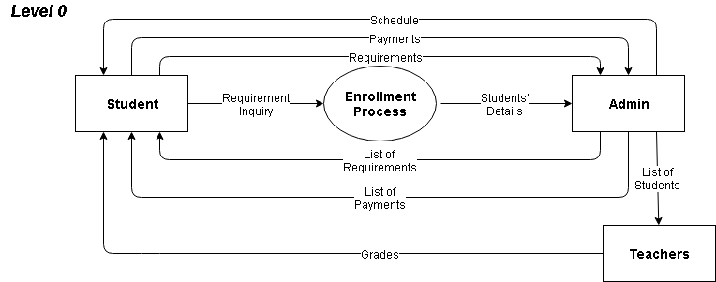

Figure 1 **Context Diagram**

To sum up Eclaro’s process from first till the end, first the student should submit his personal details to the admin then the admin would provide the list of requirements that the student should met. After completing these requirements, the student should submit it directly to the admin. The admin will provide the list of fees when the student had completed the requirements. The student will submit the payments to the admin as well. The teachers would be the responsible personnel to manage the grades of the students. Firstly, they will receive the list of students, and then will generate the grades in the end of the quarter and the students will receive their grades through a report card.

* 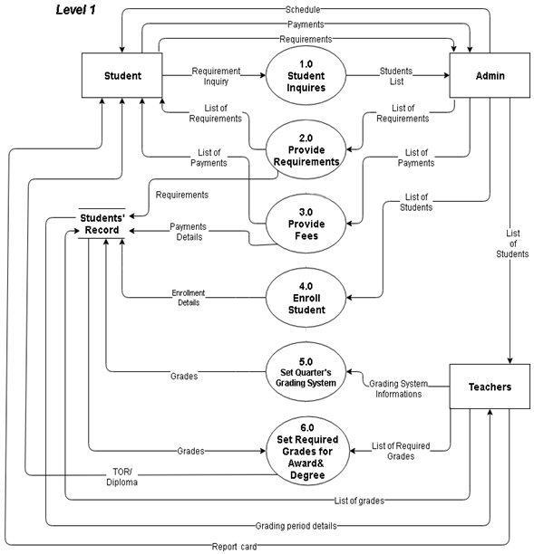**Level 1 DFD**

Figure 2 **Level 1 DFD**

The Student should inquire first to the academy, the admin will receive the list of students who inquired then the admin will provide the list of requirements that a student must comply. When the requirements are completed, the student should submit it to the admin directly, and then the admin will provide the list of fees that the student should pay to continue the process. The student must submit the payments to the admin as well. The requirement and payment details will be stored on the students’ record. The admin will now enroll the students to the academy, and store the enrollment details of each student. The teachers will receive the list of students from the admin then the teacher will provide the grading system of the quarter that the students should completed. In the end, the grades of the students will be stored in the Students’ Records then the teachers will provide the list of required grades that a student should meet in order to receive an award or to pass the quarter until they graduate to receive a degree and a TOR. The students will receive their report cards in the end of each quarter. The grades of the students will be the basis if a student deserves a reward and if a student should graduate. If students have met the requirements to receive an award, well then the student will receive the award. If students manage to graduate, they will receive the TOR and their Diploma when the academy is ready to release them.

* 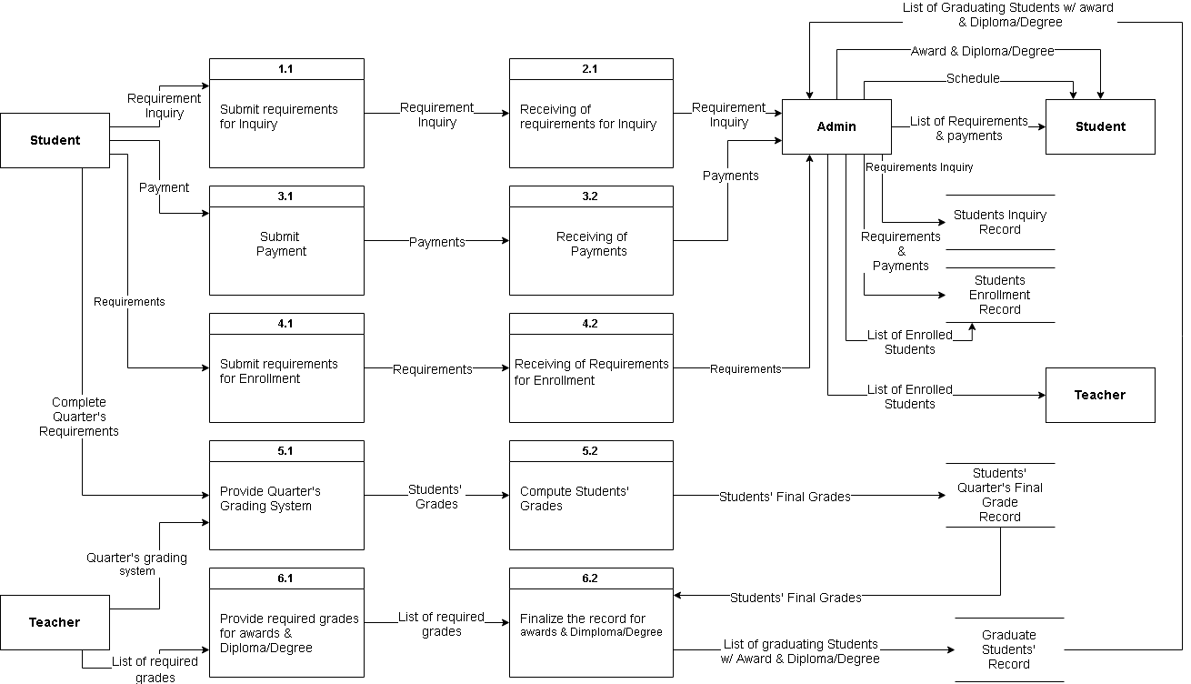**Level 2 DFD**

Figure 3 **(Level 2 DFD)**

Students will inquire to the Admin’s office of Eclaro Academy. Student will submit their information directly to the Admin then the Admin will store the student’s information to the Students’ Inquiry records. Then the Admin will provide the list of requirements and payments that the students must comply and once the students completed the requirements and paid the payments, they must submit those directly to the Admin. Then the Admin willstore the students’ submitted requirements and payment details to the Students’ Enrollment records. The Students will now receive the schedule from the admin. The admin will then enroll the students and store the list of enrolled students to Students’ Enrollment records.

The Teachers will receive the list of enrolled students from the Admin. And the Teachers will provide the Quarters’ grading system that the students must complete. Once the quarter is done, the Teachers will compute the Students’ final grades then store it to Students’ Quarters’ Final Grade Records. To generate the awards that the Students will receive, the Teacher will list the required grades that a student should meet in order to receive a reward and of course to be able to graduate. The Teacher will finalize the record for awards and diploma/degree. The list of graduating students that will receive the degree/diploma along with the list of students who will receive awards will be provided as well by the Teacher. This list will be stored to Graduate Students’ record and the Admin will use this list to distribute the diploma and awards to designated students.

* + 1. **Data and Process**

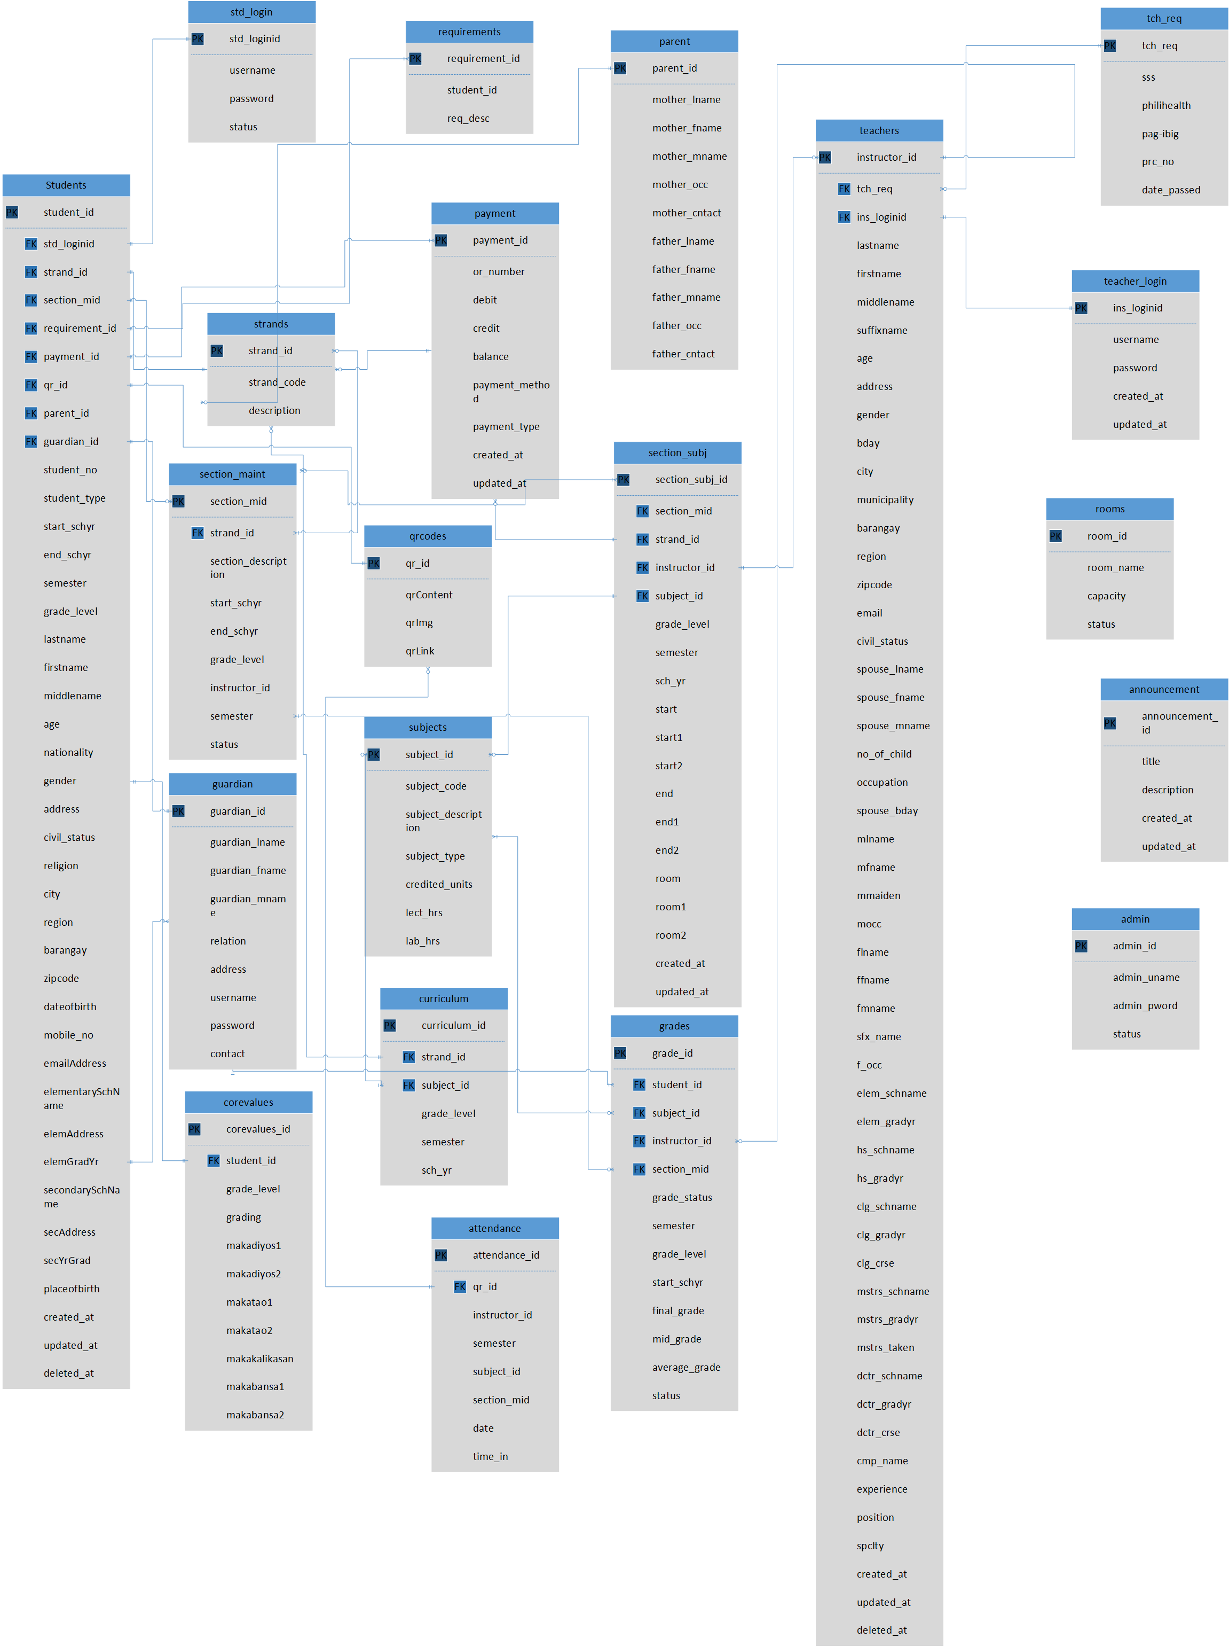

Figure 4 **ERD Diagram**

Admin is a strong entity, as the primary entity to connect the teacher's and student's. The admin entity participates totally in the one to many in relationship with teachers and students Each student must be enrolled by admin, so the students’ entity participates totally in the many to one relationship with admin Student and teacher are related through the many-to-many relationships. Student entity will provide requirements in admin entity and admin will keep the requirements of the student.

* 1. **Problem Analysis**
     1. Fishbone Diagram

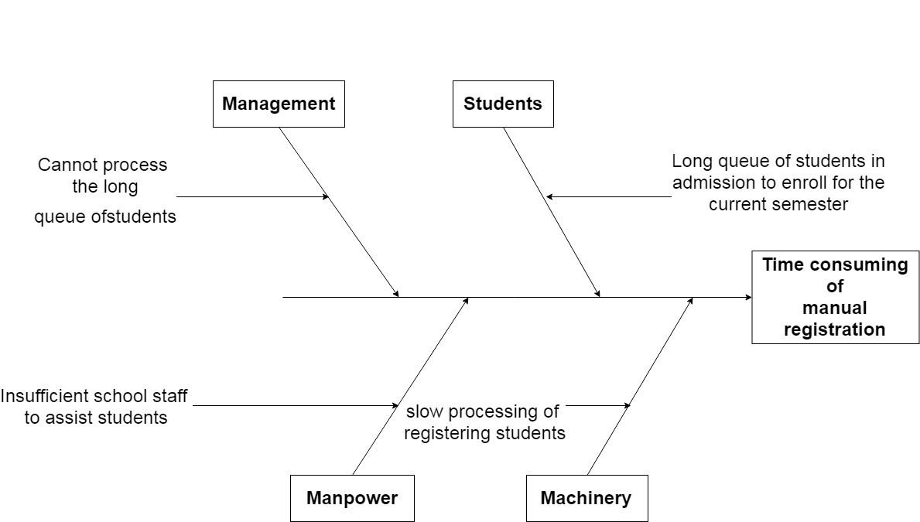

Figure 5 **Fishbone Diagram (1)**

First problem that we focused is the time consuming of manual registration. For Students, the long queue of students in admission office to enroll for the current semester is the first cause of our first problem. For the Management, they are not able to process the long queue of students quickly. The lack of machinery is also one of the causes on this problem which why the process of registering students are slow. Lastly, the lack of school staff that could assist the students is also a cause of this problem and we considered this as Manpower.

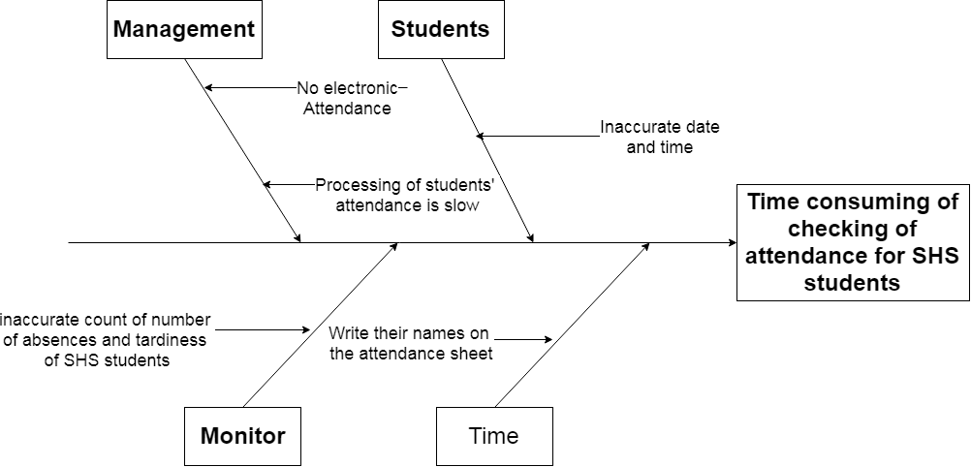

Figure 6 **Fishbone Diagram (2)**

Second problem is the time consuming of checking the attendance for Senior High School Students. Student has instances to have an inaccurate date and time in terms of checking the attendance.Second is the Management. There is no electronic attendance that could fasten the Schools are also inaccurate which makes it the third cause of this problem. Writing down the names of present students on the attendance sheet could also consume the time and the last cause of this problem.

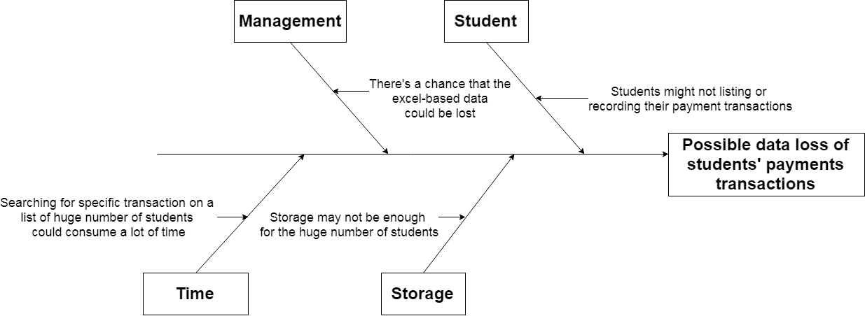

Figure 7 **Fishbone Diagram (3)**

Eclaro Academy has no database to keep their data of payment transactions in a safe place without worrying to lose them. They’re currently using a excel-based data store where they input all the transactions and save them. There’s a possibility for them to lose these transaction files so our system will provide a database for this. For this problem, Students can also benefit for the system in case they’re not listing or making a record of their payments transaction with the admin. And as mentioned, Management could lose their excel-based data. The system would be useful both for the management and the students since it consumes a lot of time when the management searchs for a specific transaction through their excel-based data. Payment transactions are important data so deleting them just like that is not a choice. Therefore, the storage for the management might not be enough and can be filled easily for the huge number of students.

* + 1. Problem and Solution

The long queue of students to enroll for the current semester is the first problem and our solution for this is by providing a web-based system for the students to enroll their subjects through online. Another one is the slow processing of registering students and our system will provide a database wherein all the Senior High School students’ attendance will be tracked and each student will be given a unique identity by generating code. The lack of school staff to assist students is also a problem and our system will provide a web-based enrollment system to lessen difficulties on the current enrollment process. Enrollment process of students is also slow and our system will solve this problem by providing privilege to allow the students to enroll online. No electronic attendance is also a problem of the Academy so the system will provide a web-based attendance that will store the attendance of every Senior High School student. The count of absences and tardiness of the students is also a problem to the academy, so the system will provide a database wherein all Senior High School students’ attendance will track and give each student a unique identity by generating code. Writing the students’ names on the attendance sheet would also consume time that’s why it’s also a problem. The system will provide a code scanner to scan every student’s generated code. Processing of students’ attendance is slow so the system will provide a reliable and sustained process to fasten processing of attendances. Invalid excuse of students is also a problem to the academy and by providing the admin staff to allow disciplinary action to the students if the excuse is invalid. Lastly, possible data loss of student payment transaction record is one of the current system problem and it can have a root causes like student might they’re not listing or making a record of their payments transaction with the admin, in management there is a possibility that data loss may encountered, searching for specific data in huge number of students consumes a lot of time and also storage may not be enough.

* + 1. Problem – Requirements Matrix

Table 4:

Problem – Requirements Matrix

|  |  |  |  |
| --- | --- | --- | --- |
| **Ref. page** | **No.** | **Problem** | **Requirement** |
| 19-21 | 1 | Long queue of students in admission to enroll for the current semester | Provide a web-based system for students to enroll their subjects via online. |
| 19-21 | 2 | Slow processing of registering students | Provide a database wherein all the SHS Students attendance will track and give each student a unique identity by generating code. |
| 19-21 | 3 | Insufficient school staff to assist students | Providing a web-based enrollment system to lessen difficulties on the current enrollment process |
| 19-21 | 4 | Cannot process fast the long queue of students | Providing privilege to allow the students to enroll online. |
| 19-21 | 5 | No electronic attendance | Provide a web-based attendance system that will store the attendance of every SHS Student |
| 19-21 | 6 | Inaccurate count of number of absences and tardiness of SHS Students. | Provide a database wherein all the SHS Students attendance will track and give each student a unique identity by generating code. |
| 19-21 | 7 | Write their names on the attendance sheet | Provide a code scanner to scan every student generated code. |
| 19-21 | 8 | Processing of students’ attendance is slow | Providing a reliable and sustained process to fasten processing attendances. |
| 19-21 | 9 | Inaccurate date and time | Provide an accurate attendance record. |
| 19-21 | 10 | Student might they’re not listing or making a record of their payments transaction | Providing a list of record for future needs of the student |
| 19-21 | 11 | Searching for specific transaction on a list of huge number of students consumes a lot of time | Providing easy access for searching specific transaction |
| 19-21 | 12 | There’s a chance that the excel based data could be lost | Providing a well organize record |
| 19-21 | 13 | Storage may not be enough for a huge number of students | Providing a huge storage for preventing data loss |

* 1. **Purpose and Description**

The following is a main proposed solution to Eclaro Academy:

* **Student Record Maintenance**

The vast amount of information generated by every student can systematically and efficiently be updated on the student data management software, thereby facilitating the administration to manage as well as organize all kinds of information, ready to be used as and when needed. The faculty can effortlessly issue updated report cards, manage student's transcripts and obtain any information on the go. A student's progress can also be tracked with the help of various analytic tools and dashboards available, which also have various types of filters for varying uses.

* **Maximum Organization with Minimal Paperwork**

The SIS with Enrollment System designed exclusively for academic institutions to help the educational campuses in streamlining and managing all the tasks involved in student admission. It makes the time consuming and hectic [process of student enrollment easy by reducing the paperwork considerably](https://www.iitms.co.in/blog/online-admission-system-for-educational-institutions.html) and digitizing each process for achieving productivity and transparency.

* **Online Registration**

The system facilitates the students in applying and registering online, thereby eliminating any kind of physical attendance for the admission process. Timely notifications and emails are sent to the students informing them about every admission process taking place online. Customization of this data can be done by the administration enabling them to be transparent in their allotment process as well as securing confidential data.

* 1. **Specific Objectives**

These are the following objectives that the researchers would like to achieve:

* To secure student information
* To monitor student accounts
* To have an accurate monitoring of SHS attendance
* To have an efficient submission of SHS grades
  1. **Scope and Limitations**

**Scope**

* Enrollment System (includes Registration of Students, Tagging of Subjects, Assessment of registered subjects)
* Electronic Attendance using QR Code for monitoring of absences and tardiness of SHS student
* Professors encoding of grades for SHS students.

**Limitation/s**

* No thru banking transactions
* Only faculties can modify student grades
* System use intranet connection

# **Chapter 2 – Reviewof Related Literature/Systems**

To establish a comprehensive background for this study, this chapter discusses the Student Information System with Enrollment System. This will also present the synthesis of the information gathered.

According to University of Toronto (2015), in the past, universities and large school districts in particular have created their own bespoke student record systems. One such example is the Repository of Student Information (ROSI) system. Most student information systems in use today are server-based, with the application residing on a central computer server, and being accessed by client applications at various places within and even outside the school. In Lovely Professional University (2017) promotes a culture of paperless University. The day to day administration and most of the University procedures are carried out online. An online portal of University is one such innovative step of the University to provide vital information regarding academics and other University logistics for assisting the University students, their parents and the staff.

Perret (2015) states the integration of SIS in the U.S.A. setting with resources to higher education systems determining that certain group of students can acquire and gain effective knowledge literacy skills through the SIS process and understanding the value of education service crafted to provide best teachings as possible.According toSafarzade&Mansoori; (2014) student information system refers to as the assembly of several subsystems based on the databases in the organization. These subsystems range from data collection, transaction processing and validating, processing, analyzing and storing the information in databases.

University of Florida (2015) explained that a student is an individual who is registered for a university credit course or program. A student record, also known as an education record, contains information directly related to a student, which means that the record is personally identifiable. Personal identifiers that relate a record to a student include student name, student ID/social security number, student address, parent/family member names, and a list of personal characteristics.

According to Evangelista (2016) the University’s Student Information System (SIS) of Nueva Vizcaya State University is a secure, web accessible interactive computer system that allows user access to grade reports, transcripts, schedule of classes, and remaining balance for the semester and register for classes online. Through the system, students would be assigned a unique identification number. All data to and from the university would use that unique identifier.

AISIS Online (2015) posted a precise definition of Ateneo Integrated Student Information System (AISIS) serves as the portal for Ateneo students, faculty and staff. Through the AISIS Online officially enrolled Ateneo students may view pertinent school information including their Individual Program of Study (IPS), grades, class schedules and the like. And in Benguet State University (2015) it would be a new way of record management and transaction processing that would achieve efficiency on processing student information. It would be a great help to the administrative personnel, academic personnel, grantors or stakeholders, and students in updating, retrieving and generating student data. In VeritasParochial School in Manila (2015) wherein itwas developed to help its students search in a more efficient way withouthassles. By logging in to their website, one can register and search their information about their subjects, instructors, and rooms that do not take morethan a few minutes to accomplish.Klaseko (2015) automate online enrollment, registration and payment systems for schools and events. Klaseko co-founder and CEO Carlo Valencia say “We significantly cut the time that families spend on the enrollment process. You see it takes a couple of hours or sometimes days. This is time they can spend on other valuable things”.

**Synthesis**

With the above mention literature, Student Information System with Enrollment System of Veritas Parochial School used web-based and databases to stores their records. Students will be logging on website, register and fill out certain forms.The AISIS Online (2015) posted a precise definition of Ateneo Integrated Student Information System (AISIS) serves as the portal for Ateneo students, faculty and staff. The Lovely Professional University (2017) promotes a culture of paperless University. And Perret (2015) states the integration of SIS in the U.S.A. setting with resources to higher education systems determining that certain group of students can acquire and gain effective knowledge literacy skills through the SIS process and understanding the value of education service crafted to provide best teachings as possible.

To sum up, the following literature reviews proves that student information system provides efficient and reliable services to the students’ andadministration. This system improved the process of searching, retrieving, viewing of subject schedules, securing student information, monitoring student accounts, having an accurate monitoring attendance and has an efficient submission of SHS grades.

# **Chapter 3 – Methodology**

* 1. **Requirements Analysis**
     1. Requirements – Features Matrix

Table 5:

Requirements – Features Matrix

|  |  |  |  |  |  |  |  |  |
| --- | --- | --- | --- | --- | --- | --- | --- | --- |
| **System Features** | **Requirements** | **RQ1:** Make the process less time consuming but still accurate | **RQ2:** Maintain student records from every semester | **RQ3:** Track every students attendance | **RQ4:** Provide every transaction safe and secured | **RQ5**: Create Database management System for all the student information | **RQ6:** Maximize the use of computer for main data storage | **RQ7:** Provide system generated reports that are usually manually create by clients |
| Provide a web-based system for students to enroll their subjects via online. |  | * | * |  | * | * | * | * |
| Provide a database wherein all the SHS Students attendance will track and give each student a unique identity by generating code. |  |  | * | * |  | * | * | * |
| Providing a web-based enrollment system to lessen difficulties on the current enrollment process |  | * | * |  | * | * | * | * |
| Providing privilege to allow the students to enroll online. |  | * | * |  | * | * | * | * |
| Provide a web-based attendance system that will store the attendance of every SHS Student |  | * | * | * |  |  |  |  |
| Provide a database wherein all the SHS Students attendance will track and give each student a unique identity by generating code. |  |  |  |  | * | * |  | * |
| Provide a code scanner to scan every student generated code. |  | * |  | * |  |  |  |  |
| Providing a reliable and sustained process to fasten processing attendances. |  | * | * | * |  |  |  |  |
| Provide admin staff to allow disciplinary action to the student if the excuse is invalid. |  |  | * |  | * |  |  |  |
| Providing a list of record for future needs of the student |  |  | * |  |  |  |  | * |
| Providing easy access for searching specific transaction |  | * |  |  |  | * |  |  |
| Providing a well organize record |  | * |  |  |  | * | * | * |
| Providing a huge storage for preventing data loss |  |  |  |  |  | * | * |  |

* + 1. Use Case Diagram

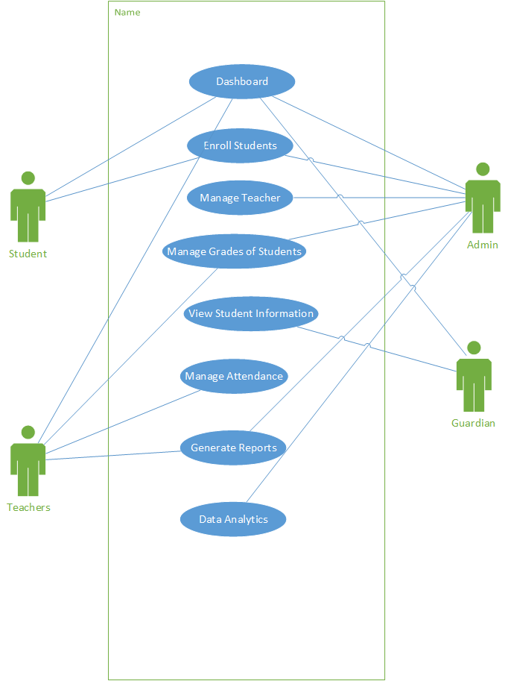

Figure 8**Use CaseDiagram**

3.1.3 Use Case Report

Table 6:

Admin Dashboard

|  |  |
| --- | --- |
| Description | |
| Use case Name: | **ADMIN DASHBOARD** |
| Actors: | Admin - responsible for adding or registering the students and teachers. |
| Purpose: | Easy monitoring and tracking of student enrollment |
| Brief Description: | Manage the school process. |
| Pre-condition: | The system must provide a form that will allow the admin to register a student. |
| Post-Conditions: | The student should know if he/she is enrolled to schools’ data. |

Table 7:

Student Dashboard

|  |  |
| --- | --- |
| Description | |
| Use case Name: | **STUDENT DASHBOARD** |
| Actors: | Students – responsible for monitoring their schedule, grades, profile, and attendance log |
| Purpose: | To easily track their grades, schedules and attendance. |
| Brief Description: | The student will manage their personal profile |
| Pre-condition: | The system must allow the students to view their personal data |
| Post-Conditions: | The student can verify if they enrolled to that particular school. |

Table 8:

Teacher Dashboard

|  |  |
| --- | --- |
| Description | |
| Use case Name: | **TEACHER DASHBOARD** |
| Actors: | Teacher – responsible for monitoring students’ attendance and encoding of grades |
| Purpose: | For easy tracking of students’ performance, attendance and monitoring behavior manners. |
| Brief Description: | The teacher will manage the grades and attendance of the students |
| Pre-condition: | The system must provide a form that will allow the teacher to manage student grades and attendance. |
| Post-Conditions: | The student can verify his/her grades. |

Table 9:

Enroll Student

|  |  |
| --- | --- |
| Description | |
| Use case Name: | **ENROLL STUDENTS** |
| Actors: | Admin – responsible for checking the requirements of students upon enrollment  Student – can enroll online |
| Purpose: | To provide real-time registration that aims to solve the school’s lack of flexibility, manpower, and time-consuming system. |
| Brief Description: | Serves as a vital part of a school for easy and convenient way of enrolling a student. |
| Pre-condition: | Enables students to enroll into their subjects prior to the commencement of their semester. |
| Post-Conditions: | The student can verify if they enrolled to that particular school. |

Table 10:

Manage Teacher

|  |  |
| --- | --- |
| Description | |
| Use case Name: | **MANAGE TEACHER** |
| Actors: | Admin – responsible for allowing the teacher to encode the grades of students  Teacher – responsible for tracking attendance and record student grades. |
| Purpose: | To update the information of every teacher in that particular school. |
| Brief Description: | To track student progress |
| Pre-condition: | The system must provide a form that will allow the teacher to manage student grades and attendance. |
| Post-Conditions: | The student can verify their grades. |

Table 11:

Manage Grades of Students

|  |  |
| --- | --- |
| Description | |
| Use case Name: | **MANAGE GRADES OF STUDENTS** |
| Actors: | Admin – responsible for allowing the teacher to encode the grades of students  Teacher – responsible for recording student grades. |
| Purpose: | Accurate computation of grades |
| Brief Description: | To collect data from |
| Pre-condition: | The system must provide a form that will allow the teacher to manage student grades. |
| Post-Conditions: | The student can verify their grades. |

Table 12:

Manage Attendance

|  |  |
| --- | --- |
| Description | |
| Use case Name: | **MANAGE ATTENDANCE** |
| Actors: | Teacher – responsible for tracking attendance of every student |
| Purpose: | Easily track student behavior |
| Brief Description: | To monitor overall student behavior |
| Pre-condition: | The system must provide a form that will allow the teacher to manage attendance of students. |
| Post-Conditions: | The student can view their attendance. |

Table 13:

Generate Reports

|  |  |
| --- | --- |
| Description | |
| Use case Name: | **GENERATE REPORTS** |
| Actors: | Admin – manages reports like enrollment of students, schedule of subjects  Teacher – manages reports of list of students, |
| Purpose: | To monitor all the reports and transactions that is displayed on the system |
| Brief Description: | List of reports and transactions that can be modified by the admin and teacher |
| Pre-condition: | The system must provide a list of records. |
| Post-Conditions: | They can generate reports |

Table 14:

Data Analytics

|  |  |
| --- | --- |
| Description | |
| Use case Name: | **DATA ANALYTICS** |
| Actors: | Admin – manages reports like enrollment of students, schedule of subjects  Teacher – manages reports of list of students, |
| Purpose: | To monitor all the reports and transactions that is displayed on the system |
| Brief Description: | List of reports and transactions that can be modified by the admin and teacher |
| Pre-condition: | The system must provide a list of records. |
| Post-Conditions: | They can generate reports |

Table 15:

View Student Information

|  |  |
| --- | --- |
| Description | |
| Use case Name: | **VIEW STUDENT INFORMATION** |
| Actors: | Guardian - can view students' information |
| Purpose: | To give guardians the privilege to monitor their students' information |
| Brief Description: | To keep the guardian aware of the students' performance |
| Pre-condition: | The system must provide the information of the student |
| Post-Conditions: | The guardian can verify if the student is enrolled to that school |

* 1. **Design Specifications**
     1. Activity Diagram

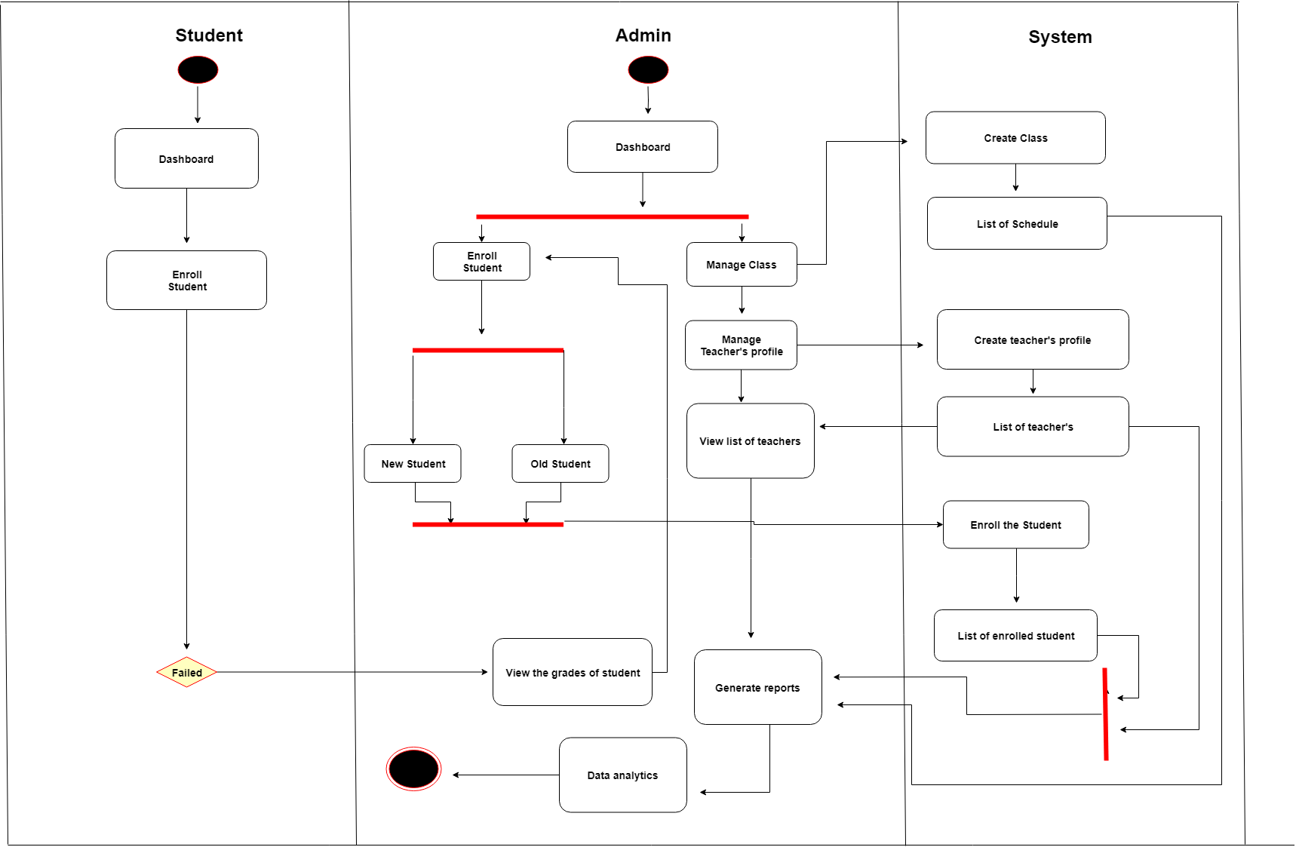

Figure 9 **Activity Diagram (Admin)**

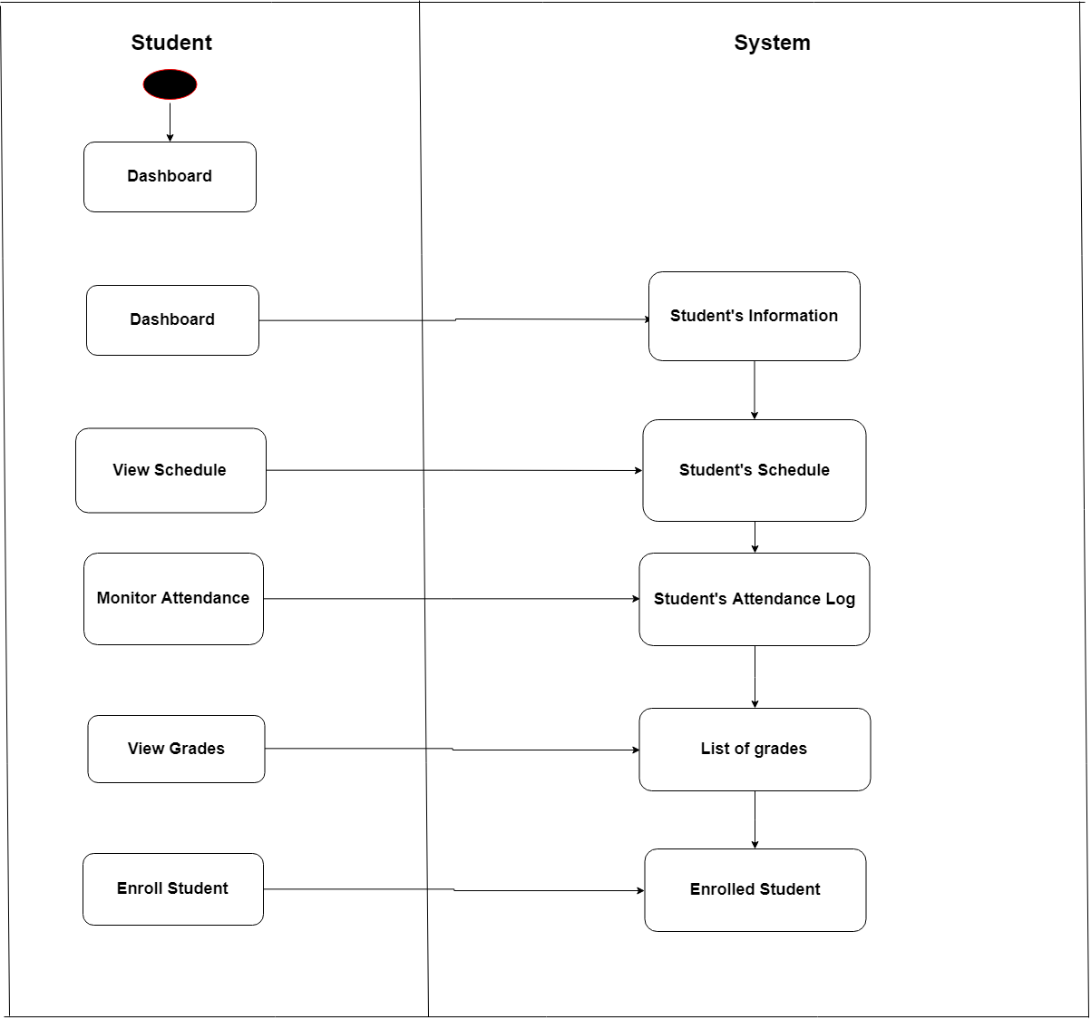

Figure 10 **Activity Diagram (Student)**

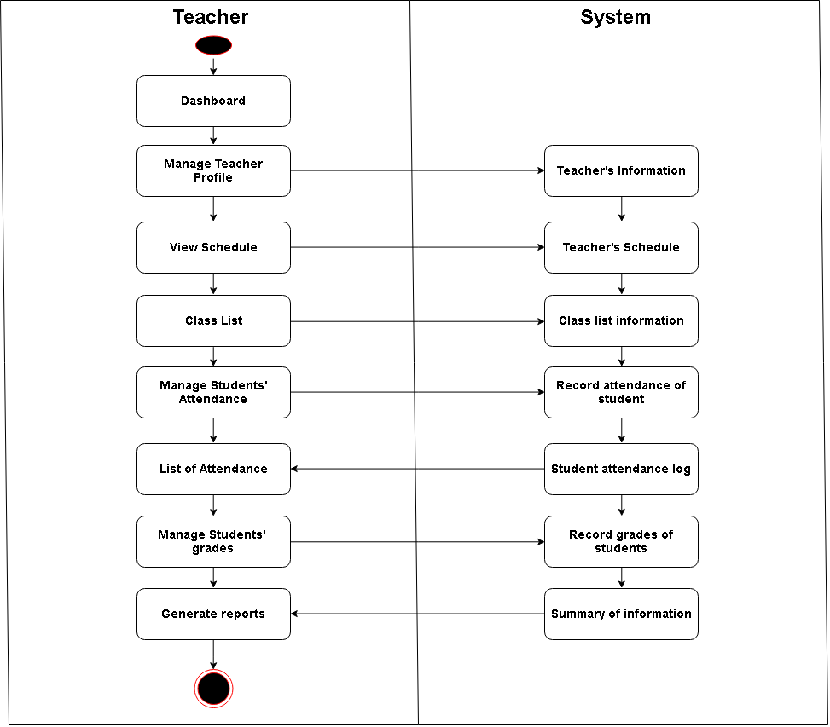

Figure 11 **Activity Diagram (Teacher)**

* + 1. Class Diagram

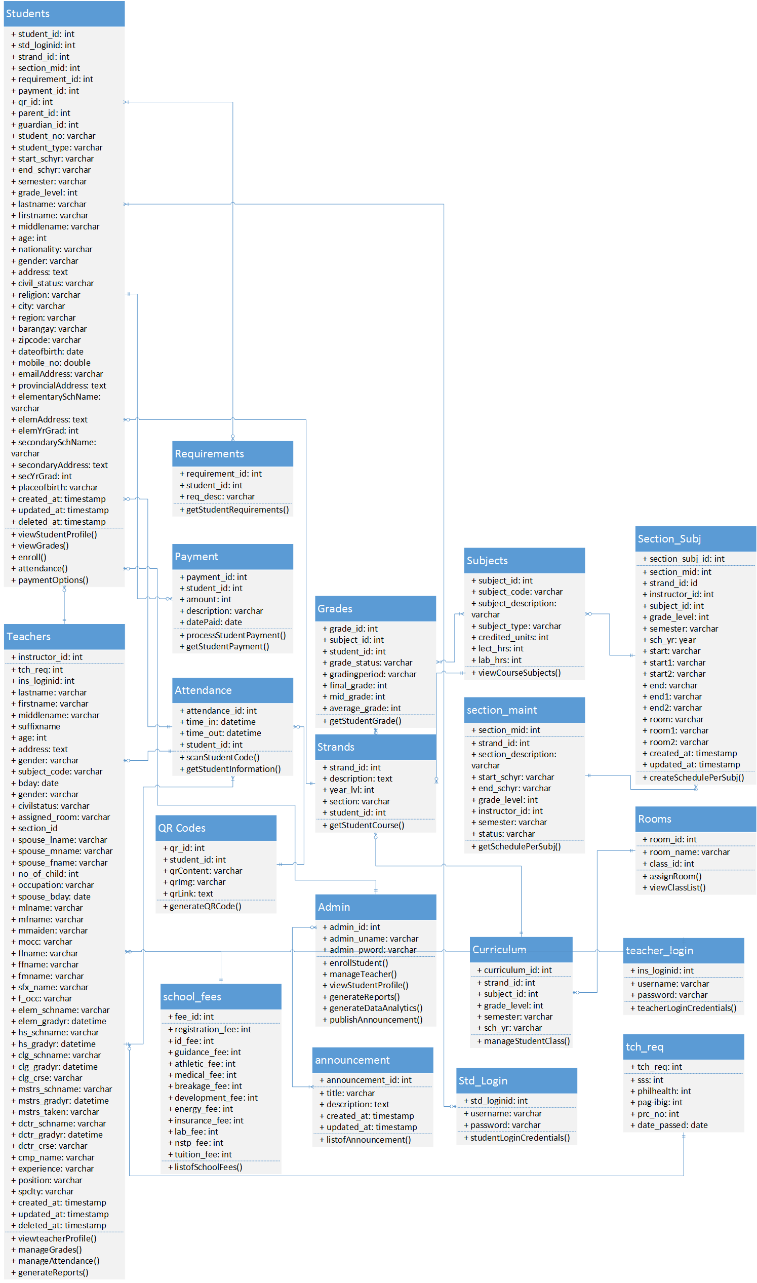

Figure 12 **Class Diagram**

* + 1. 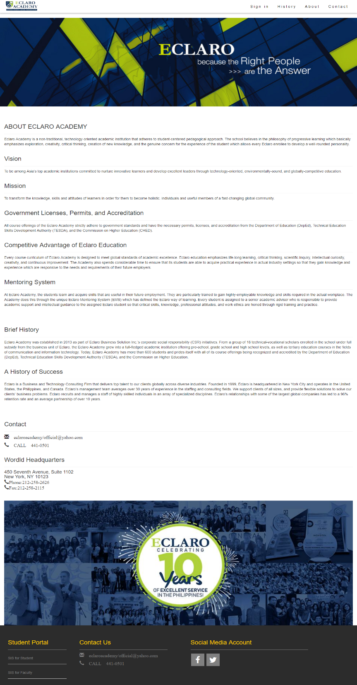GUI Design (screen shots)

Figure 13 **Front Page**

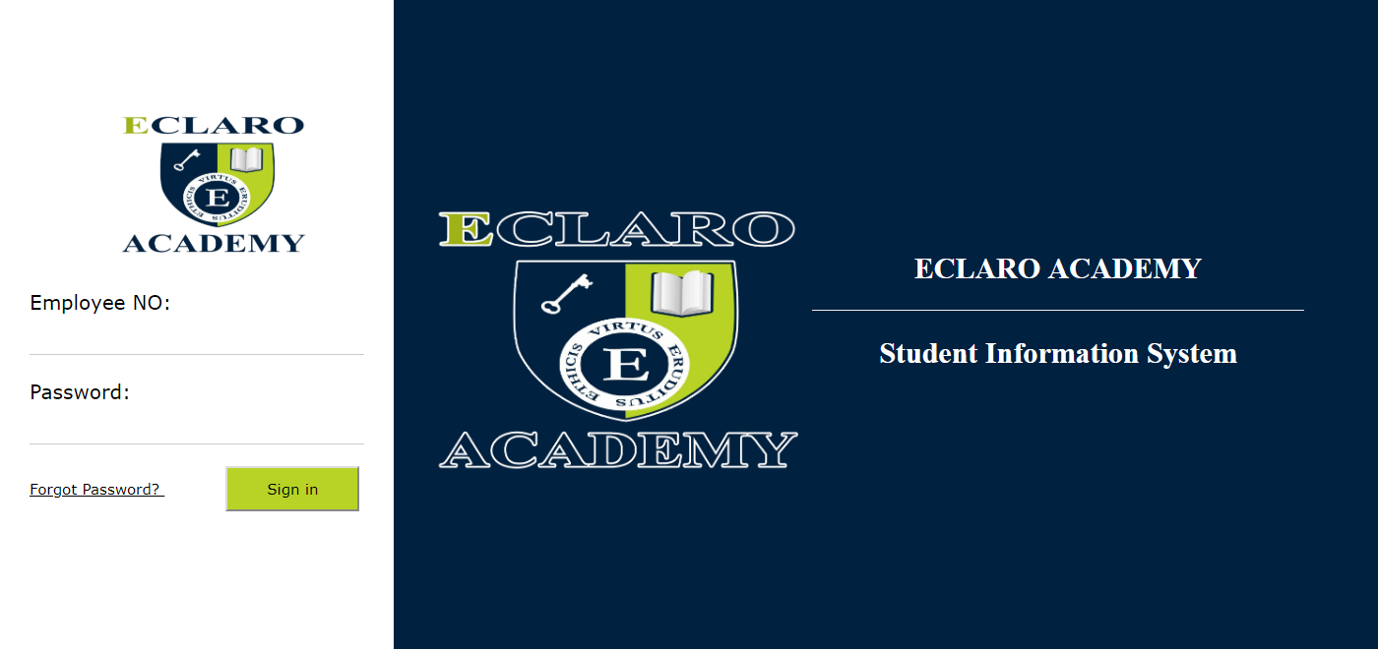

Figure 14 **Login Page (ADMIN & TEACHER)**

**ADMIN:**

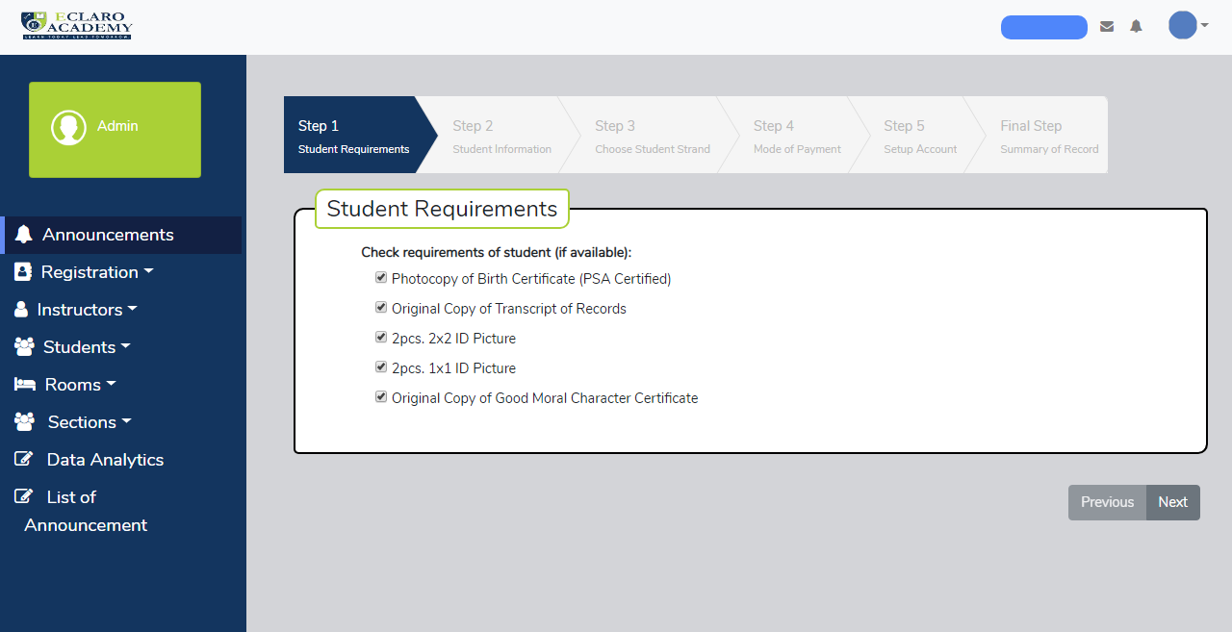

Figure 15 **Step 1 - Student Registration: Requirements**

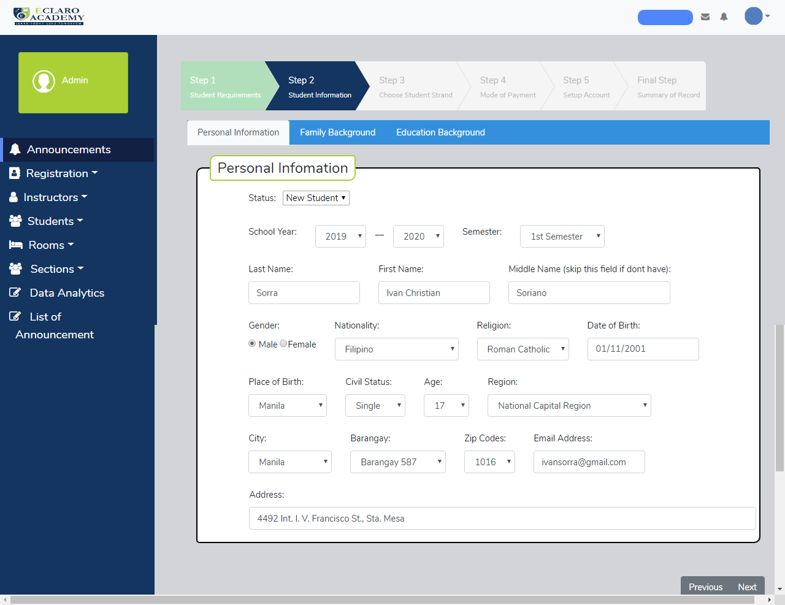

Figure 16 **Step 1- Student Registration: Personal Information**

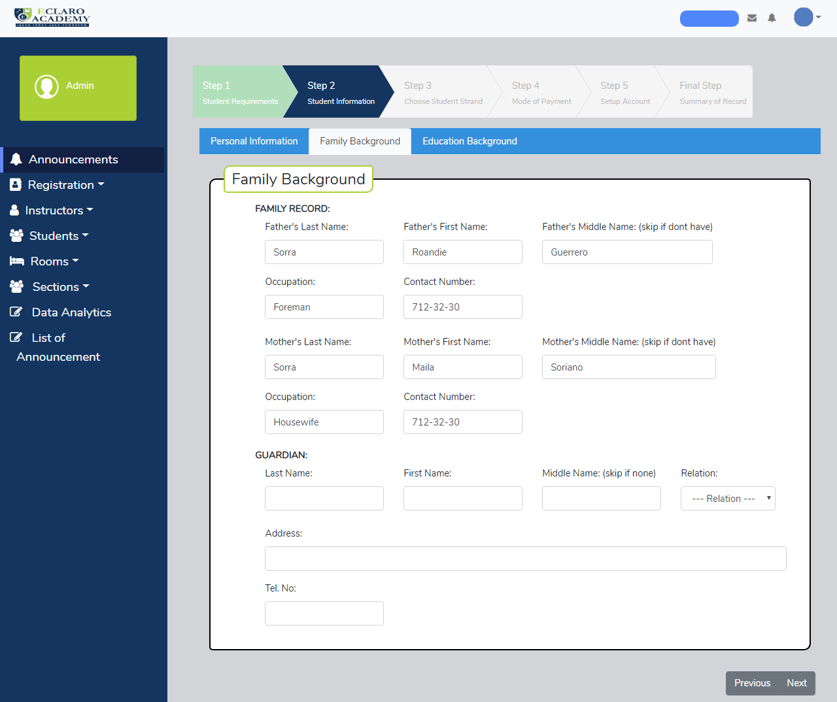

Figure 17 **Step 1- Student Registration: Family Background**

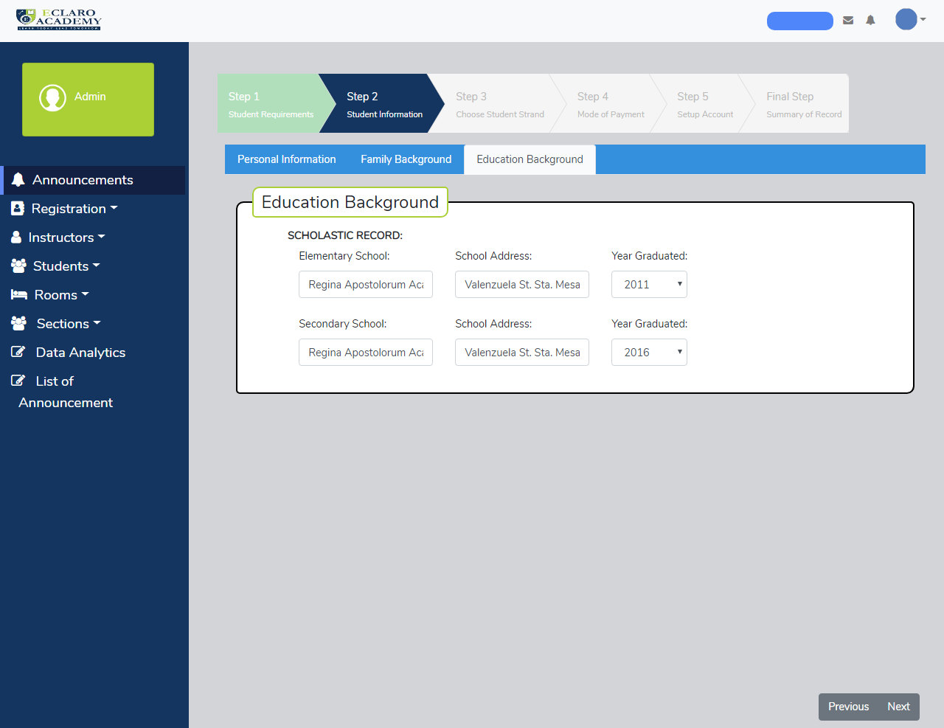

Figure 18 **Step 2- Student Registration: Educational Background**

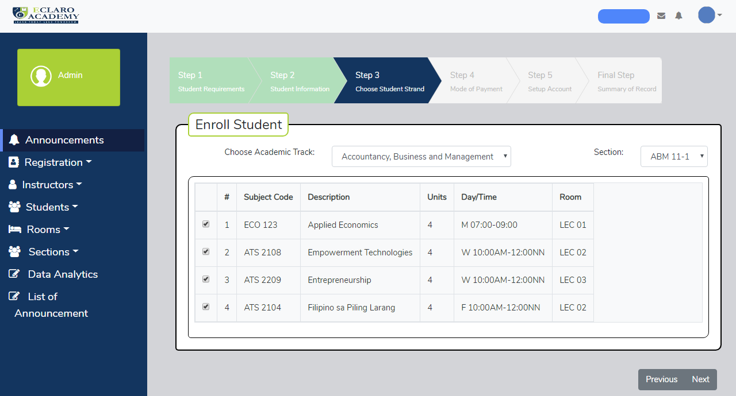

Figure 19 **Step 3- Student Registration: Choose Strand and Section**

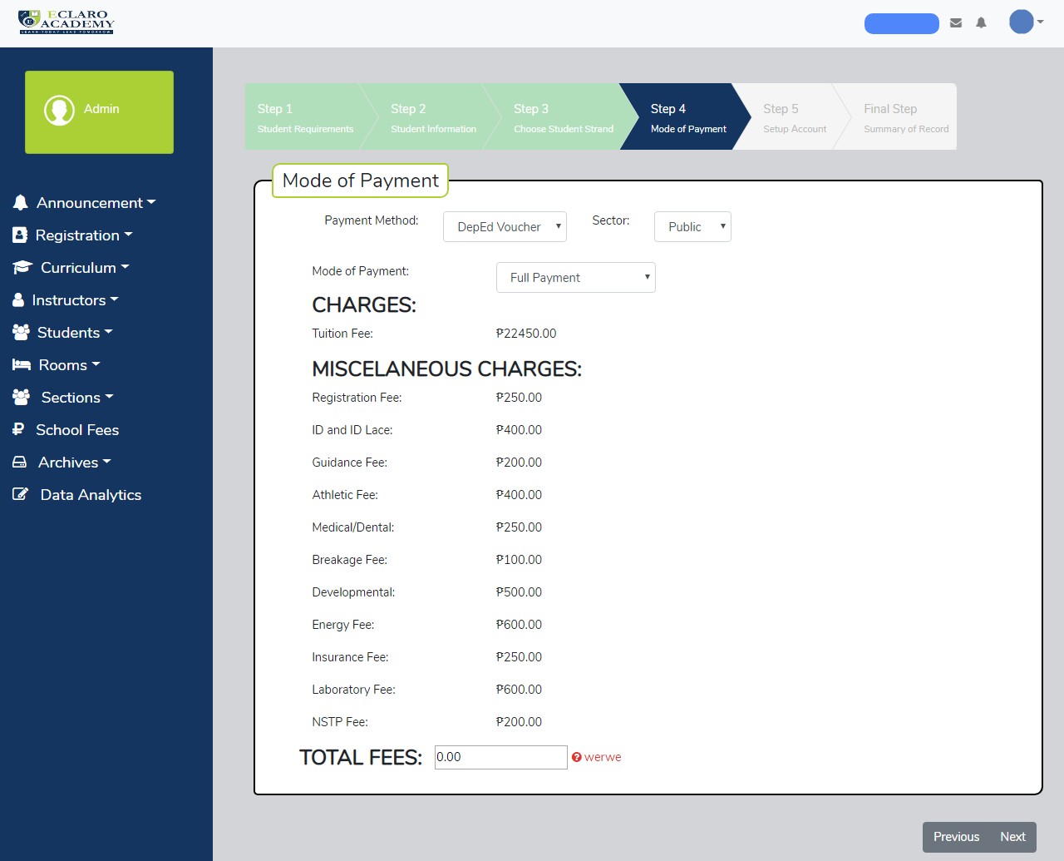

Figure 20 **Step 4- Student Registration: Mode of Payment**

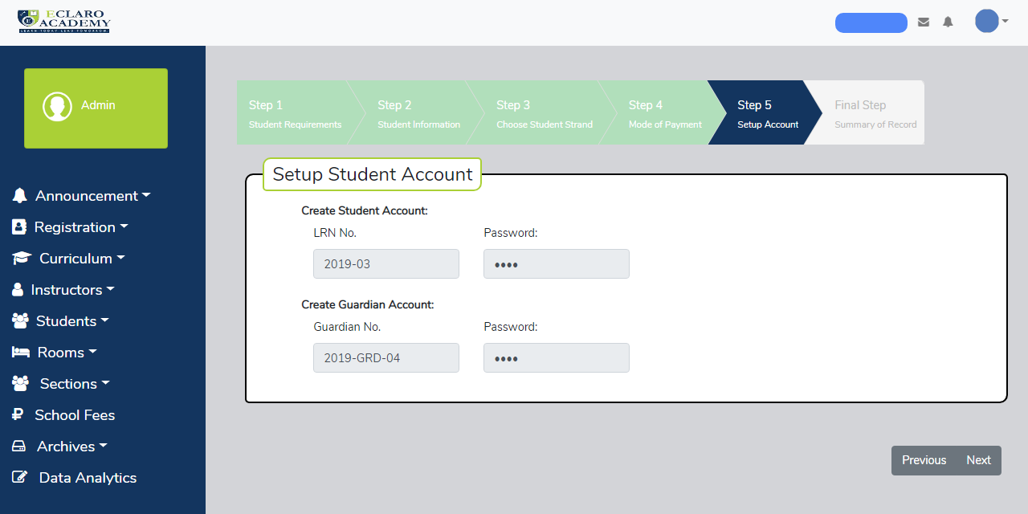

Figure 21 **Step 5- Student Registration: Setup Student Account**

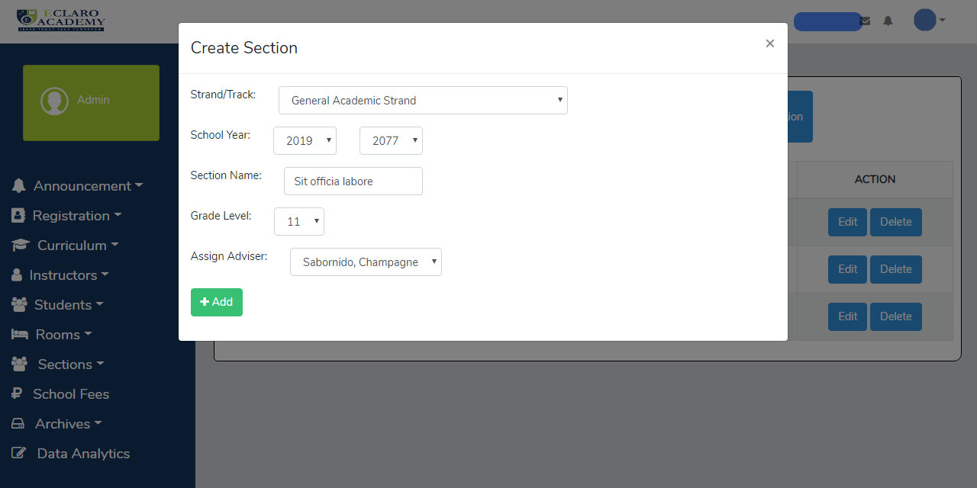

Figure 22 **Create Section**

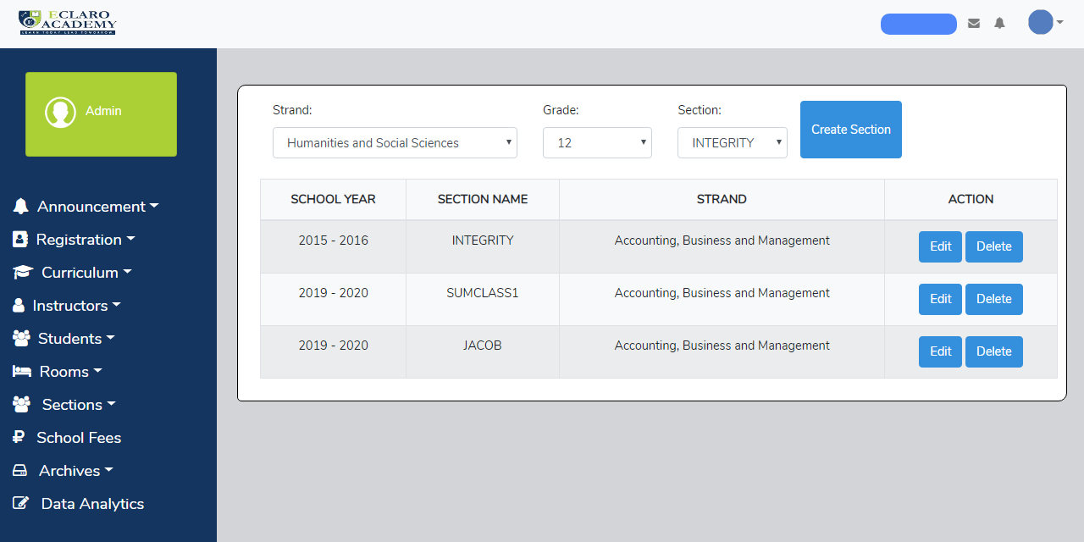

Figure 23 **List of Section**

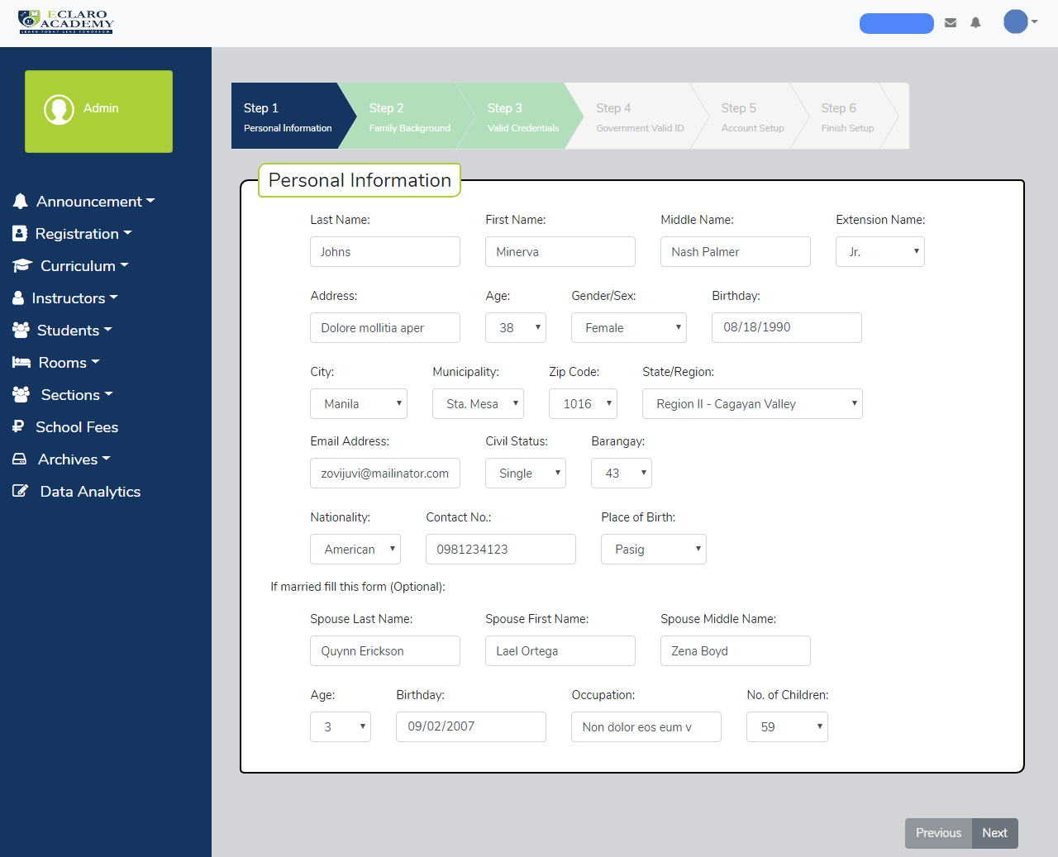

Figure 24 **Step 1- Teacher Registration: Personal Information**

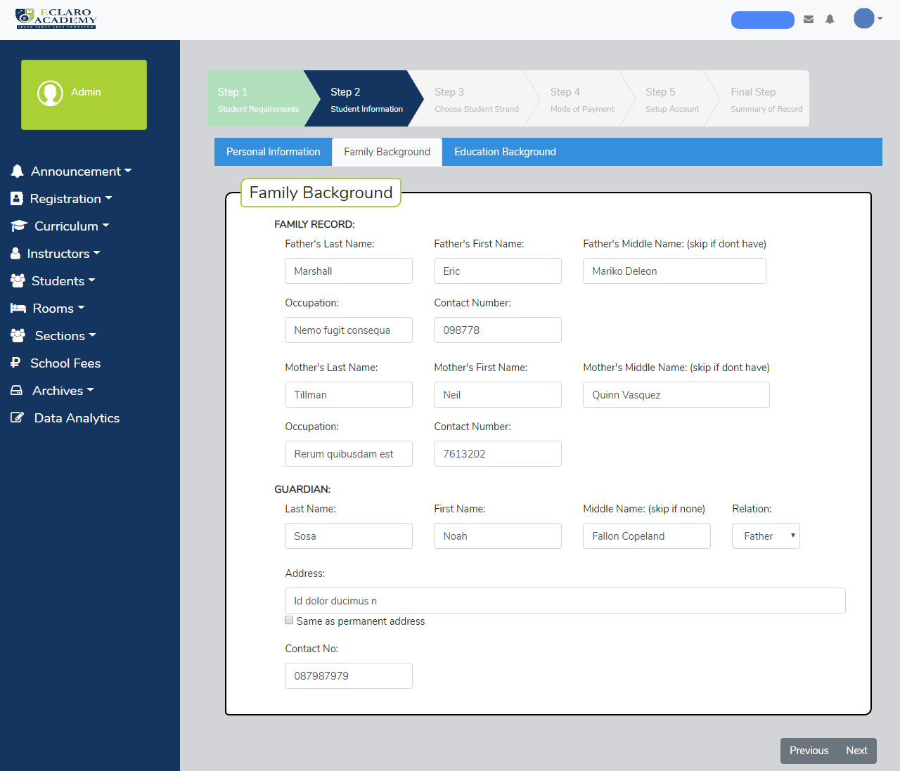

Figure 25 **Step 2- Teacher Registration: Family Background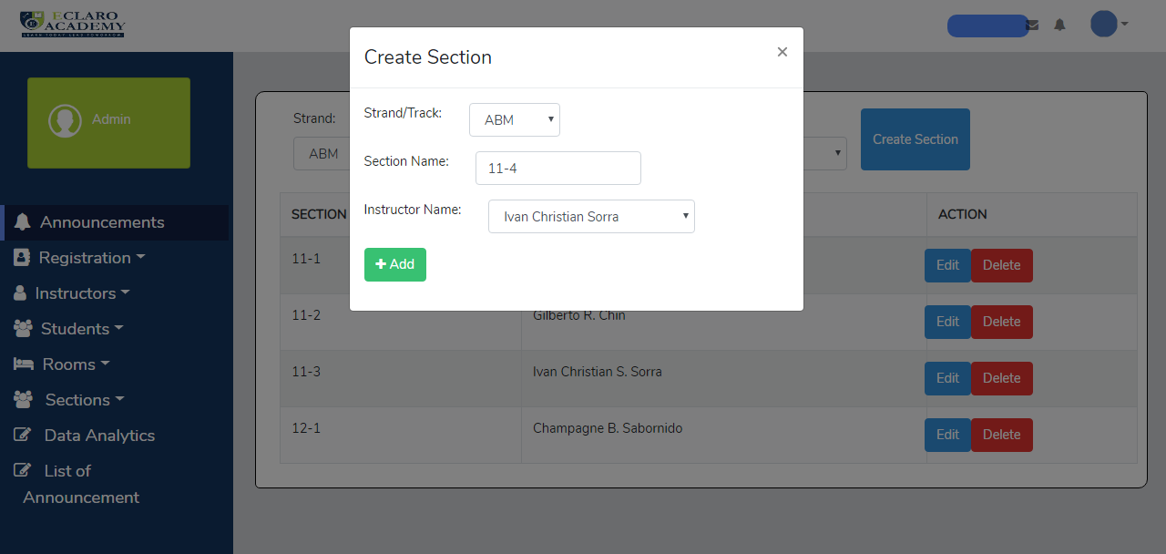nformation**

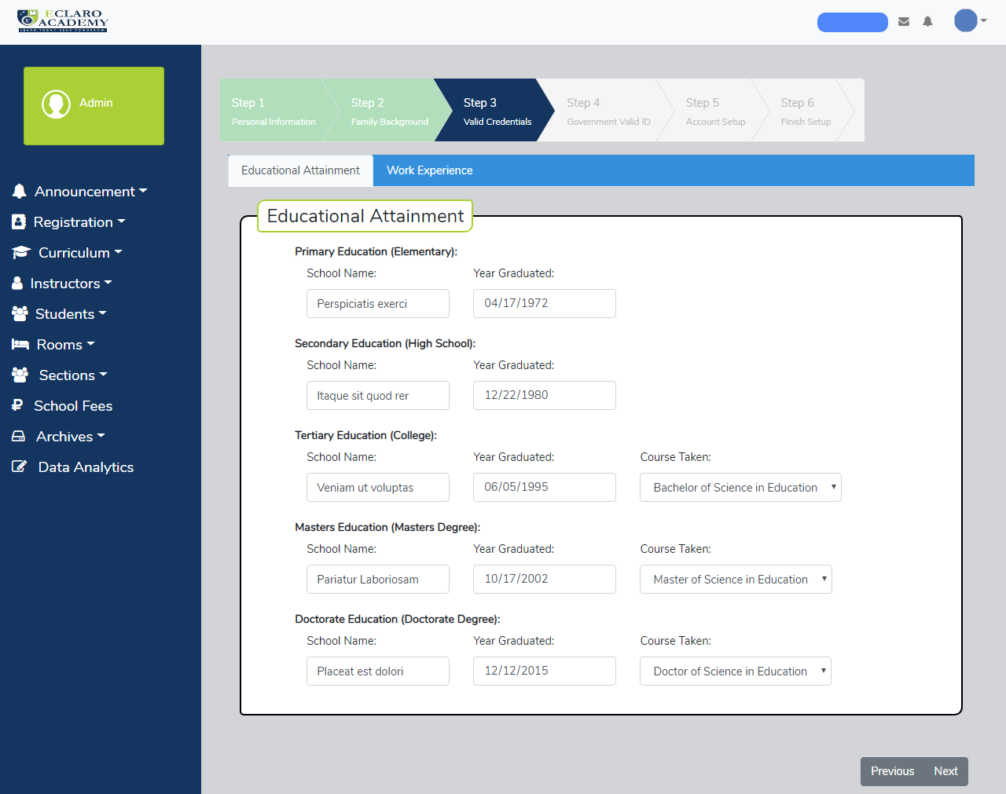

Figure 26 **Step 3- Teacher Registration: Valid Credentials**

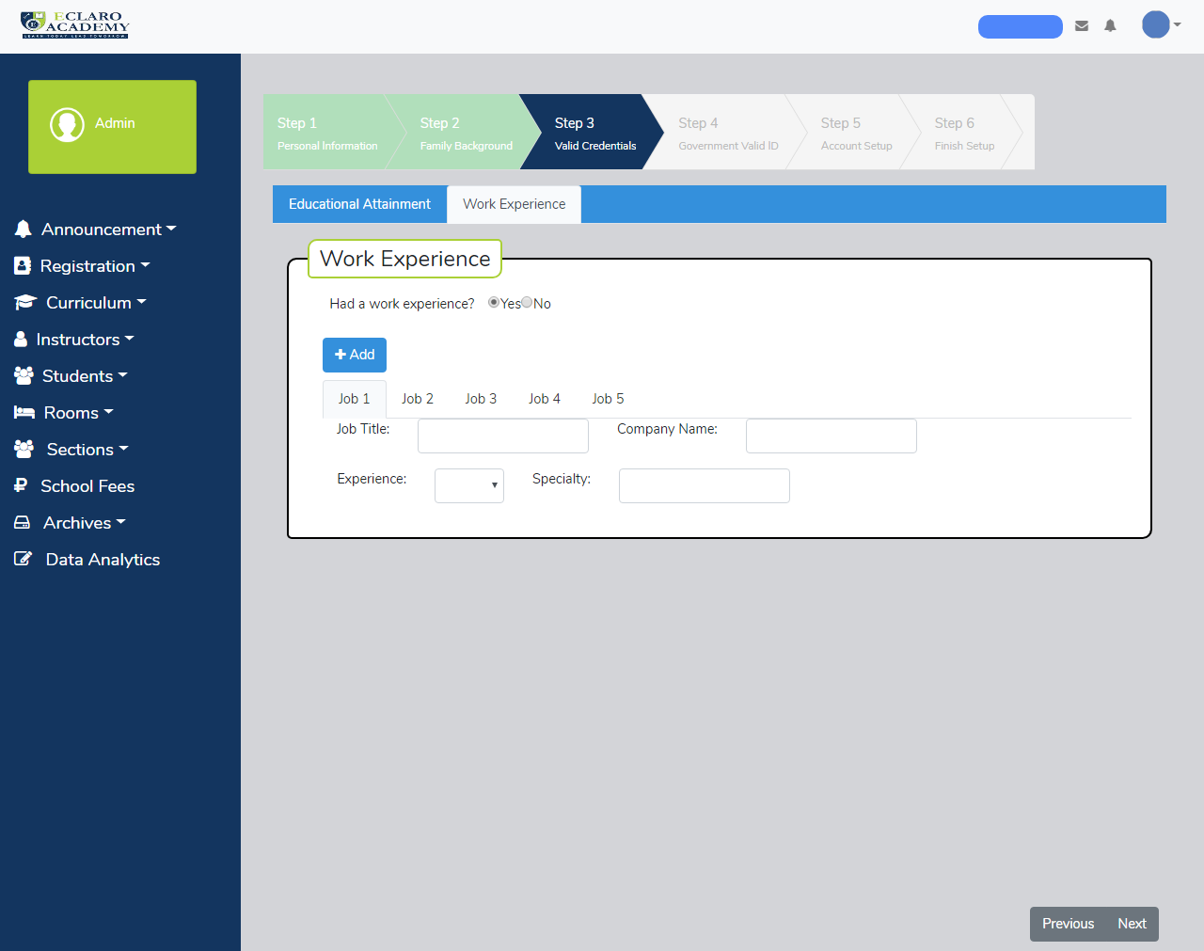

Figure 27 **Step 3- Teacher Registration: Work Experiences**

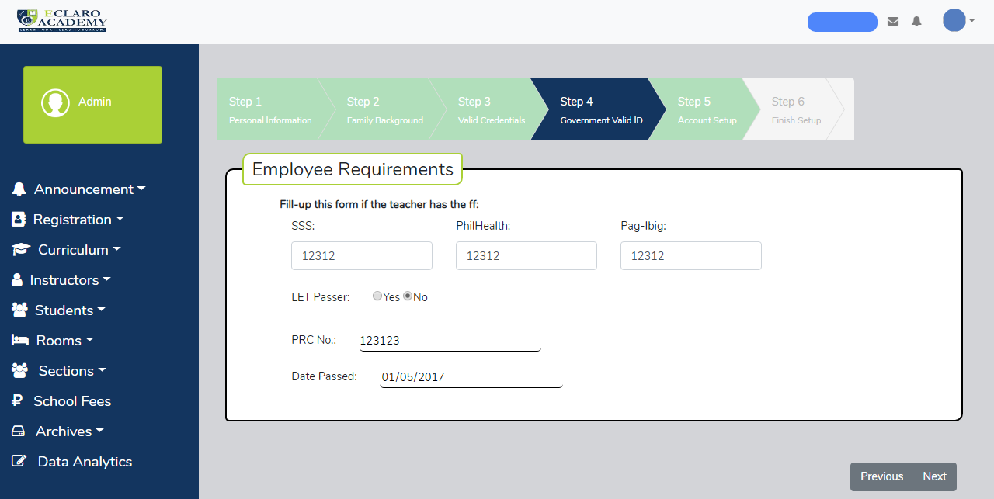

Figure 28 **Step 4- Teacher Registration: Employee Requirements**

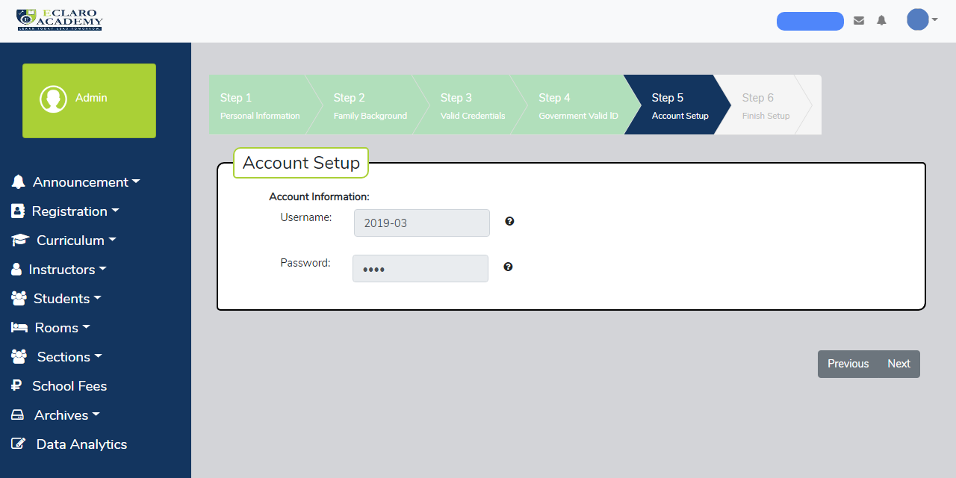

Figure 29 **Step 5- Teacher Registration: Setup Account**

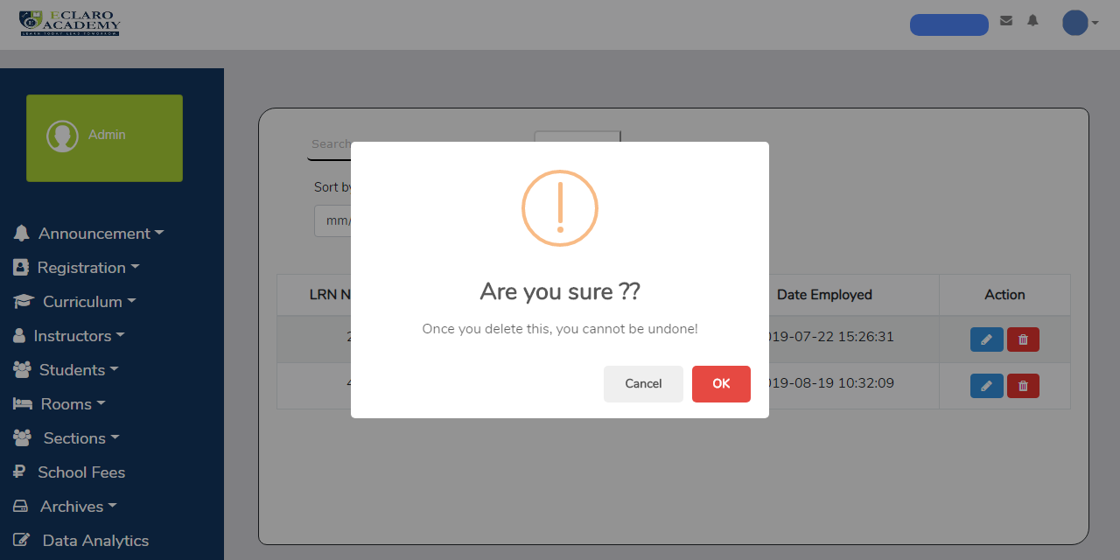

Figure 30 **Move to trash (Teacher)**

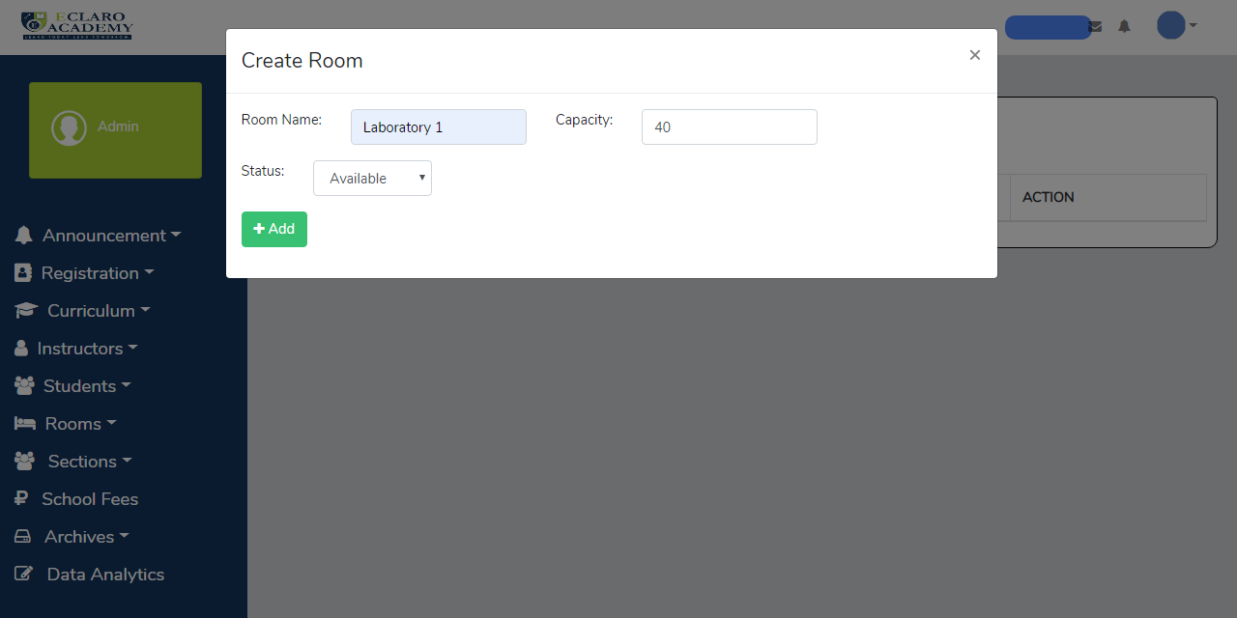

Figure 31 **Create Room**

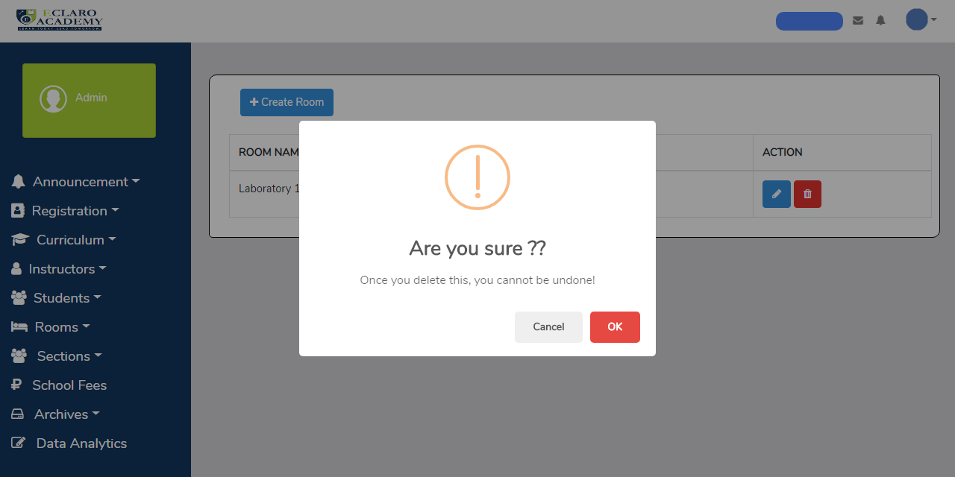

Figure 32 **Delete Room**

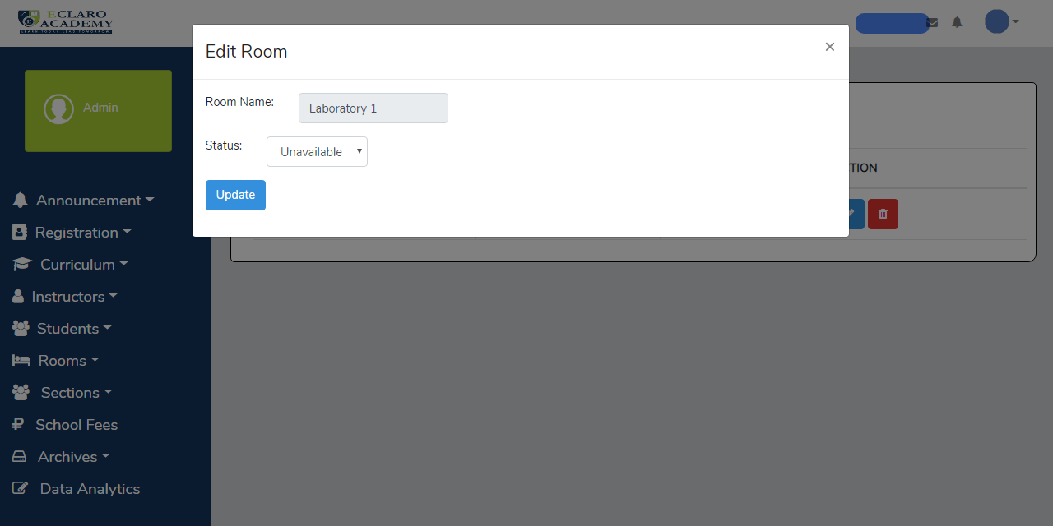

Figure 33 **Edit Room**

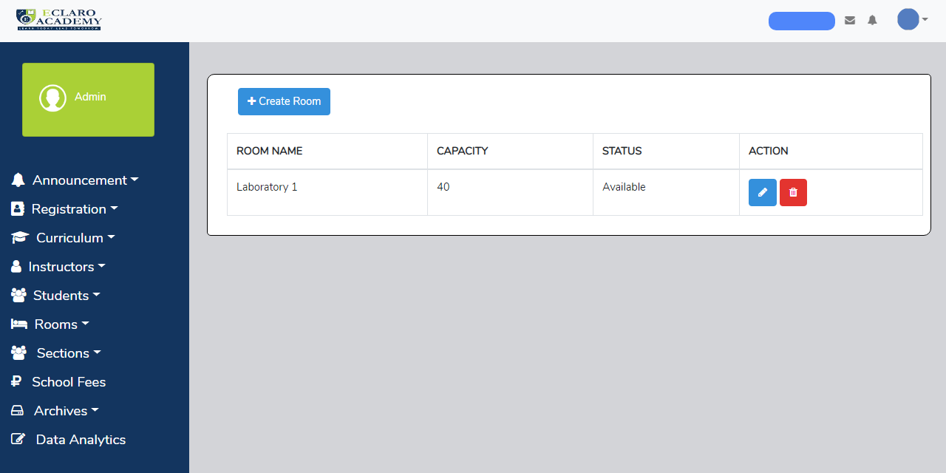

Figure 34 **List of Rooms**

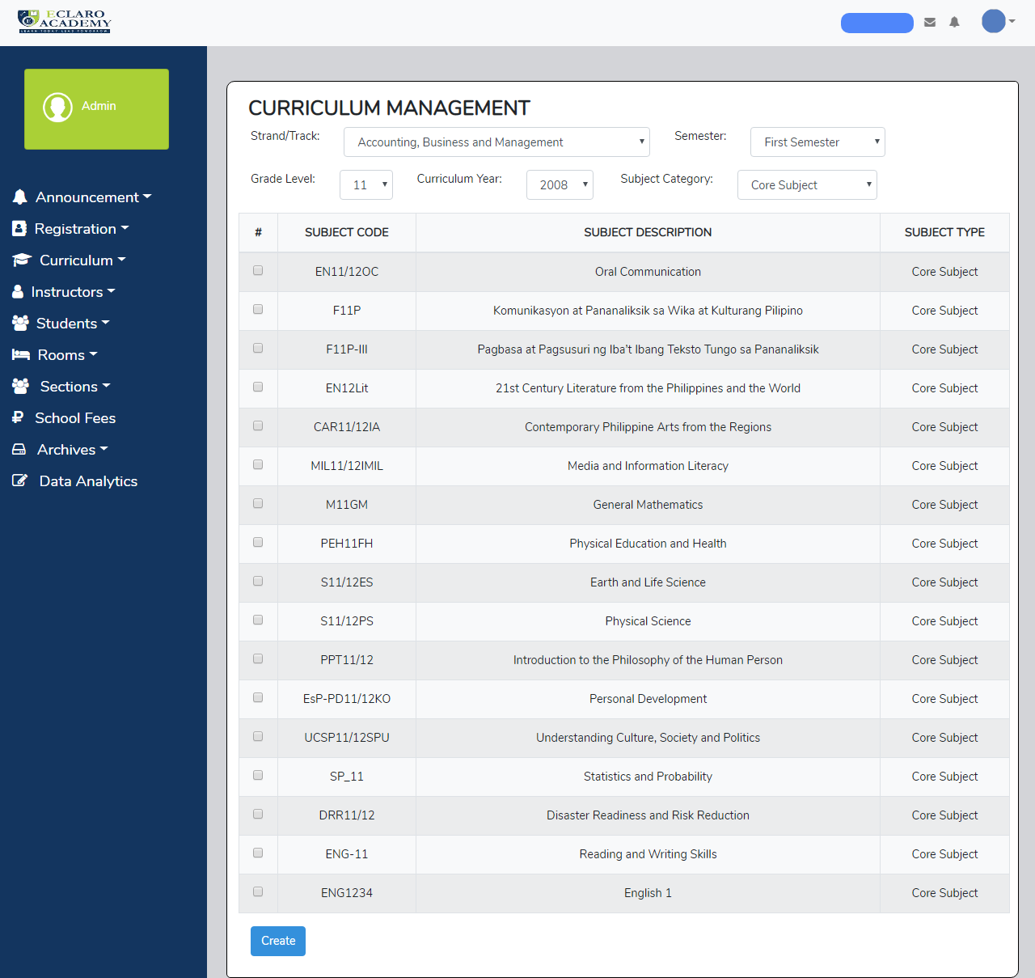

Figure 35 **Create Curriculum**

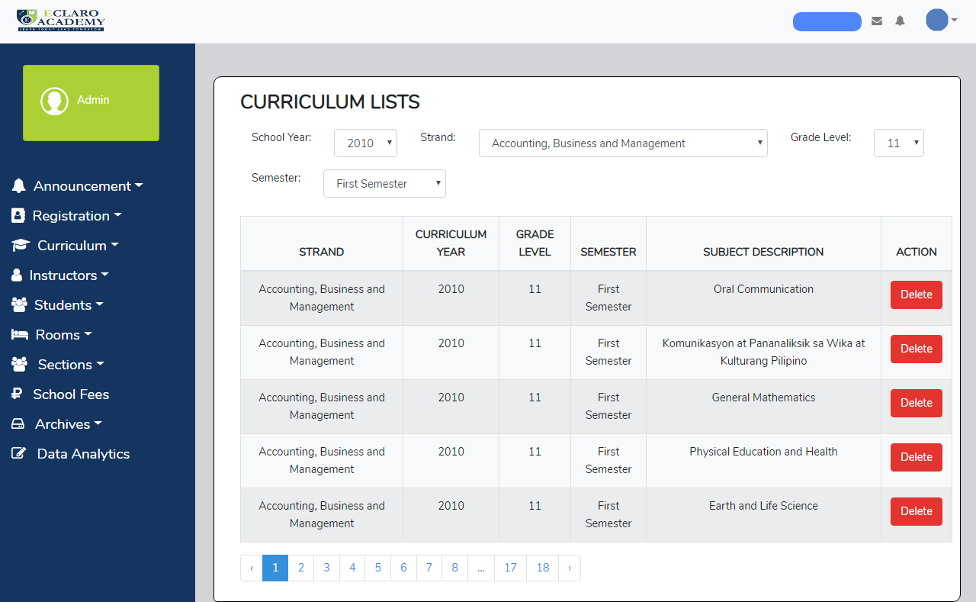

Figure 36 **List of Curriculum**

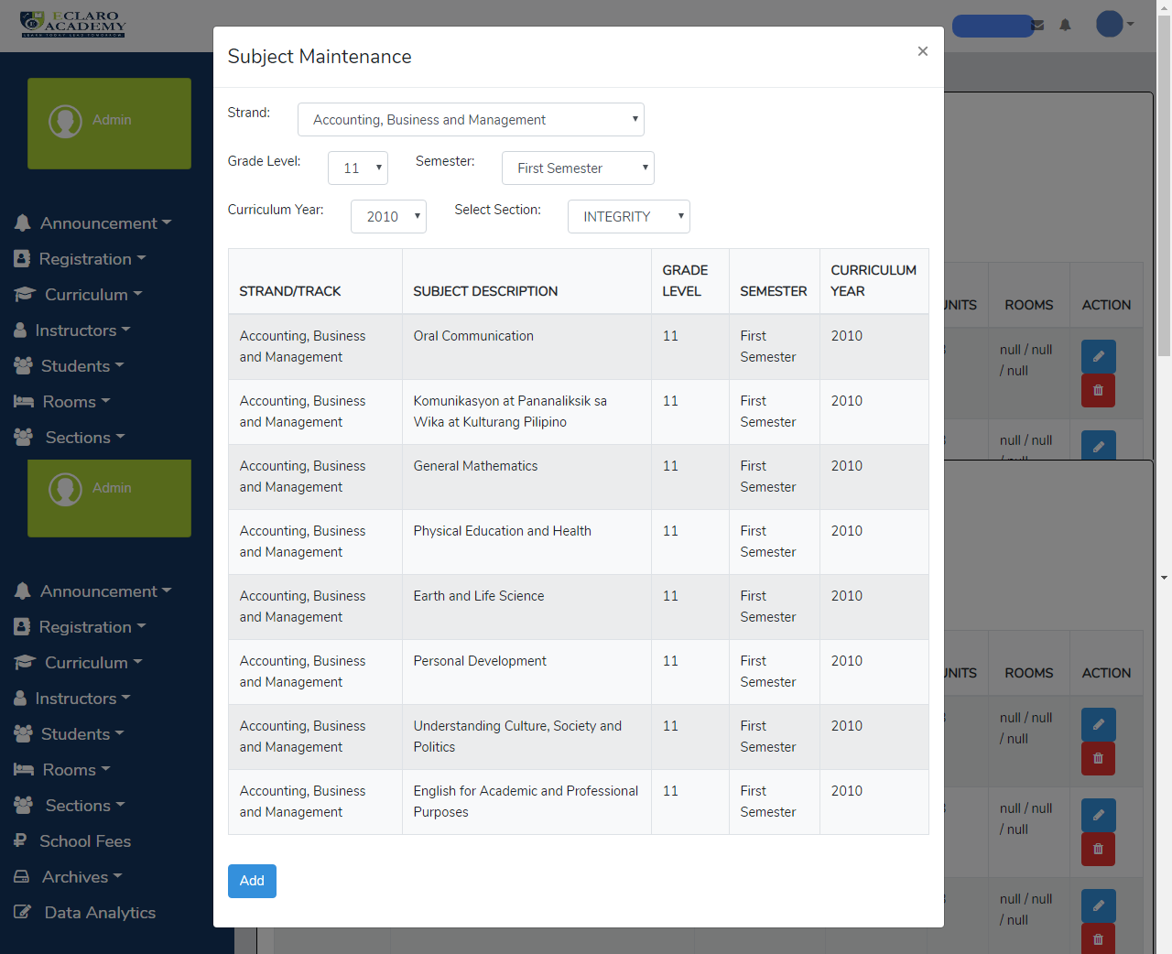

Figure 37 **Applying Subject to Section**

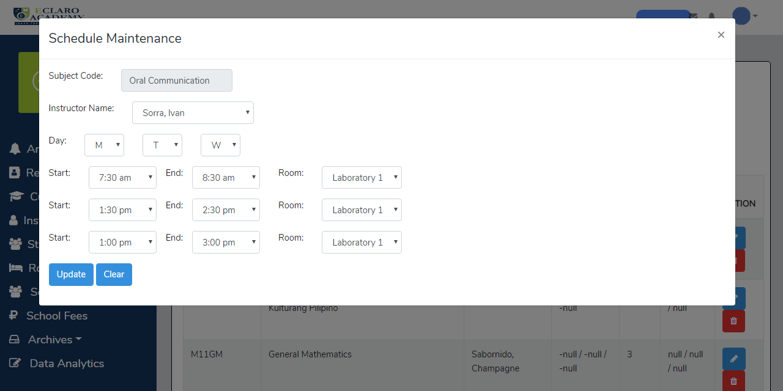

Figure 38 **Setting Schedule, Teacher and Room in Section Subject**



Figure 39 **List of Sections**

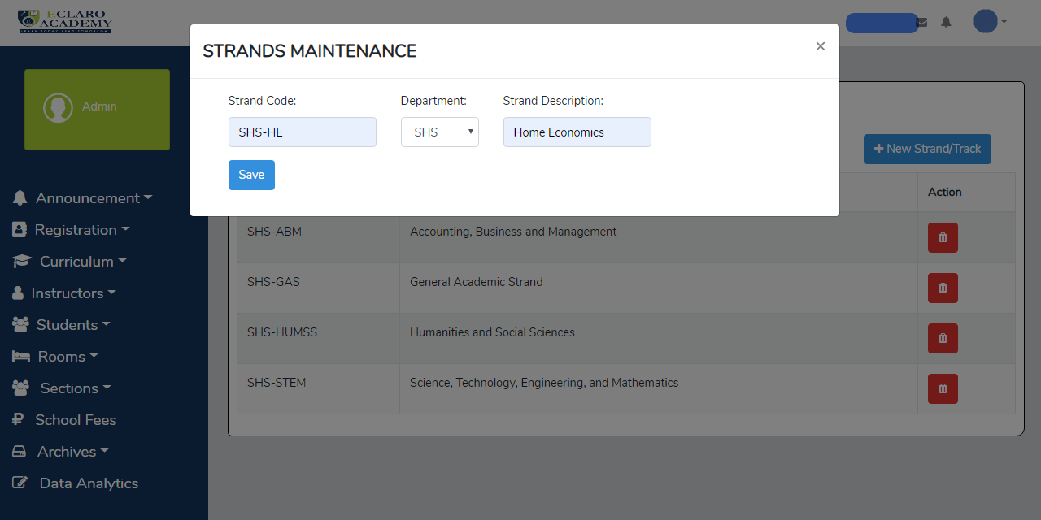

Figure 40 **Making Strand**

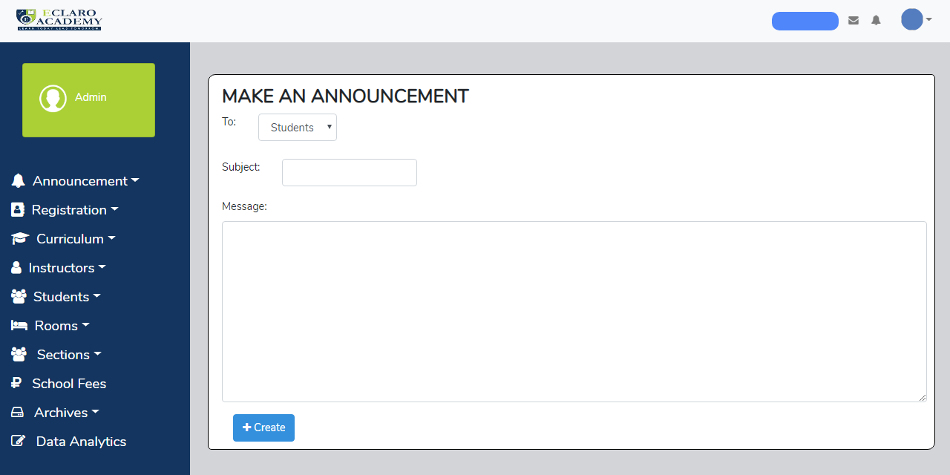

Figure 41 **Making Announcement**

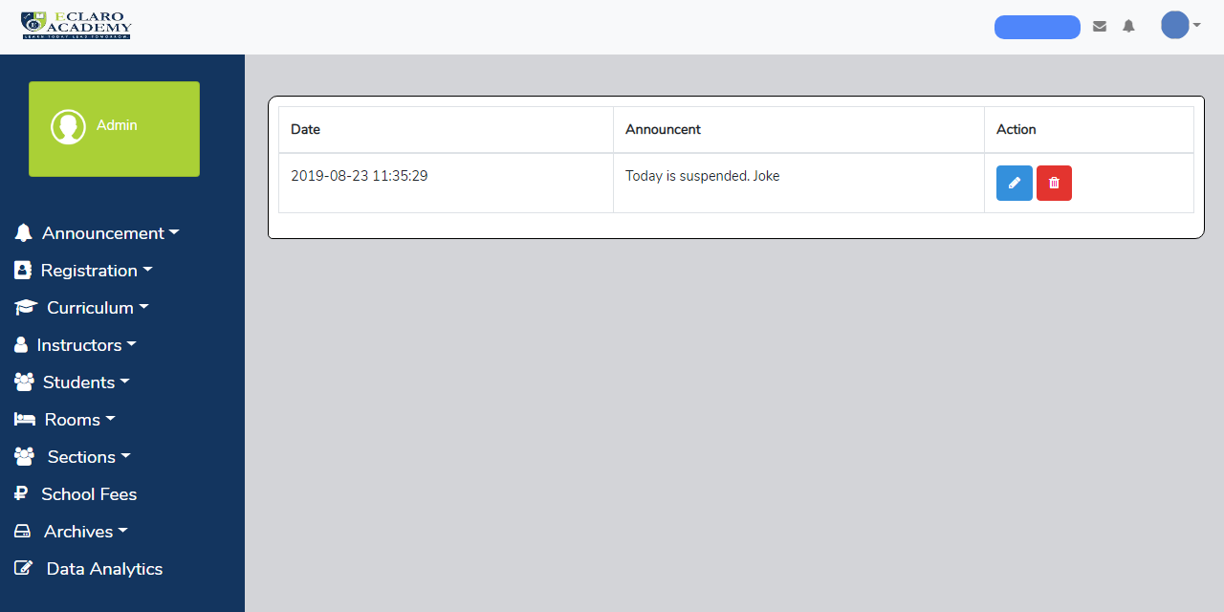

Figure 42 **List of Announcement**

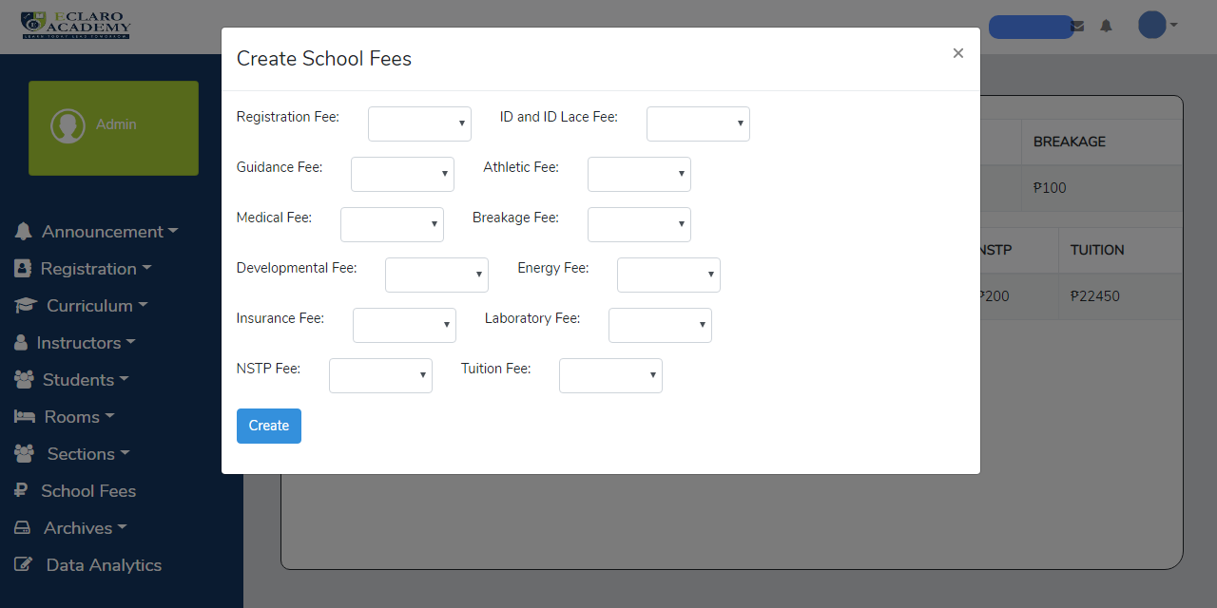

Figure 43 **School Fees**

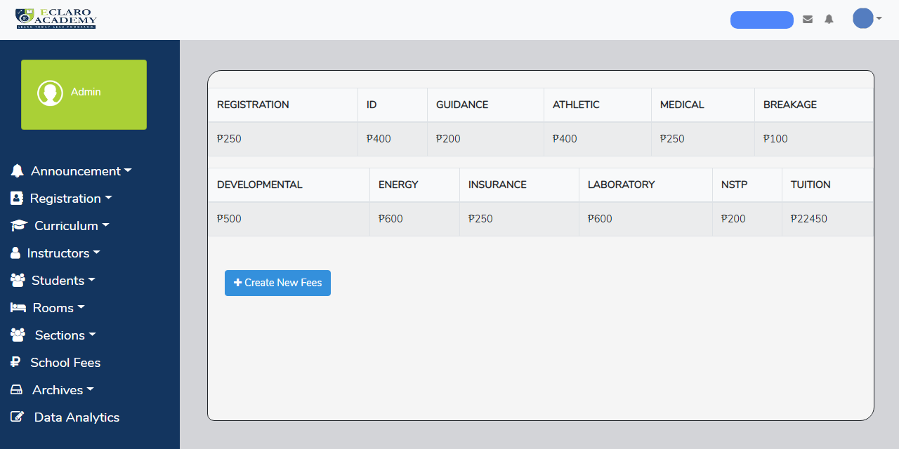

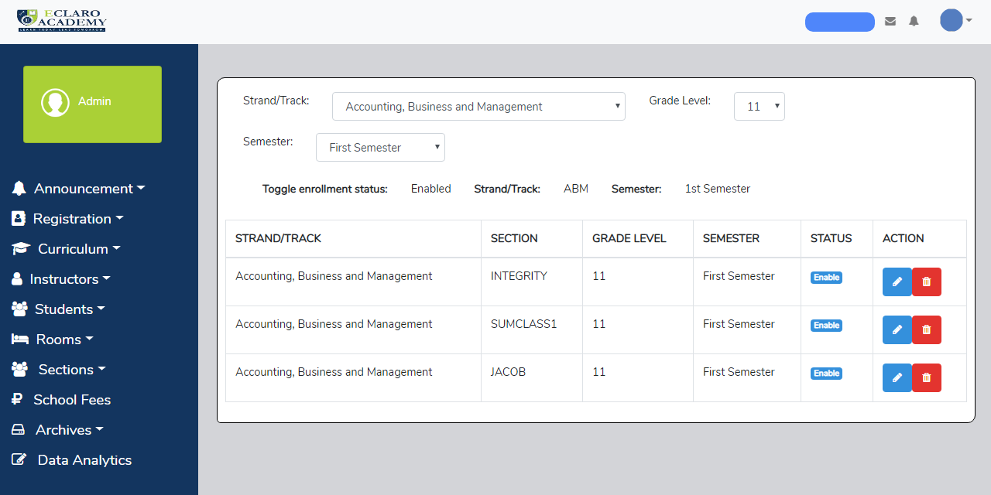

Figure 44 **Lists of School Fees**

Figure 45 **Toggling of Enrollment**

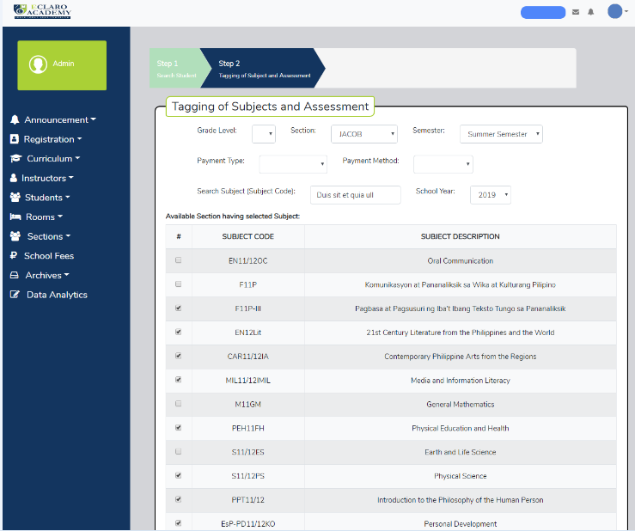

Figure 46 **Retake Subject for Failed Student**

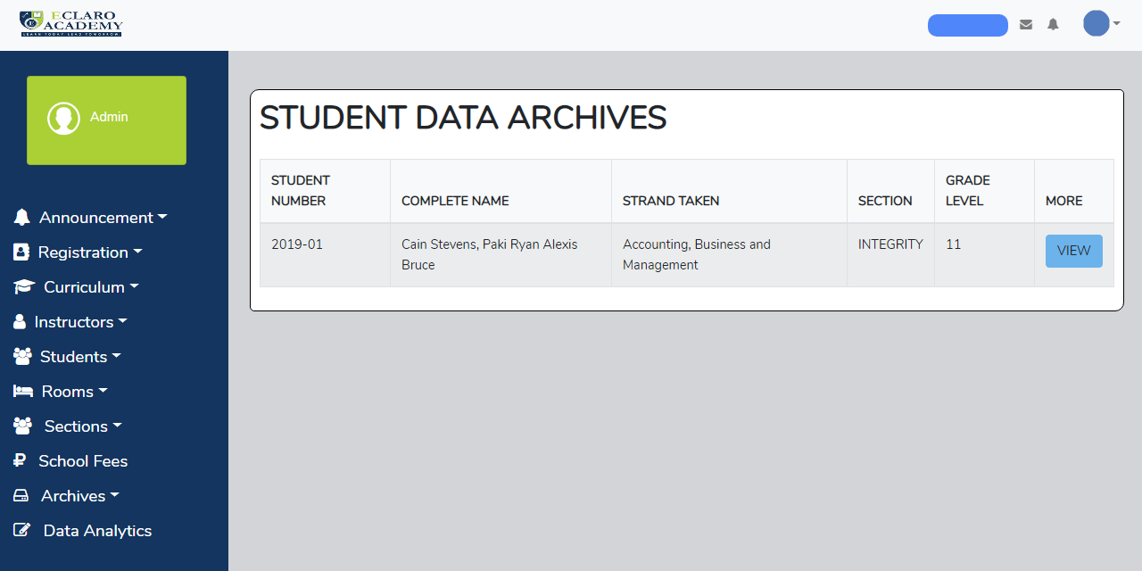

Figure 47 **Archive of Student**

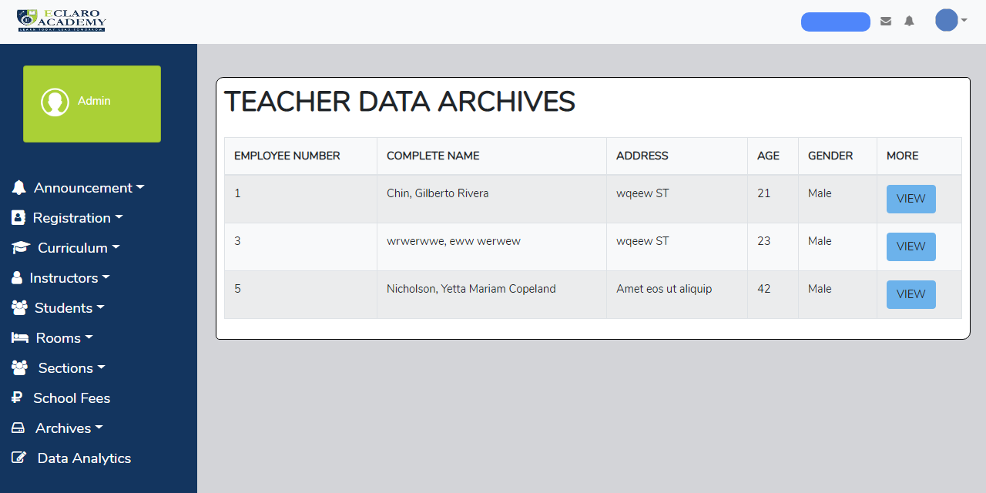

Figure 48 **Archive of Teacher**

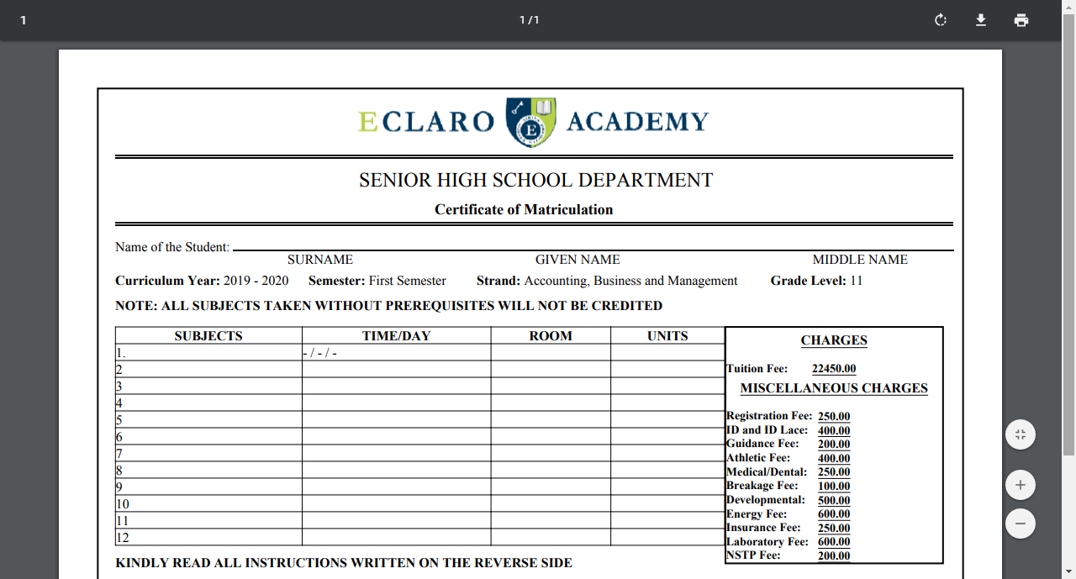

Figure 49 **Reports: Registration Card**

**STUDENT DASHBOARD:**

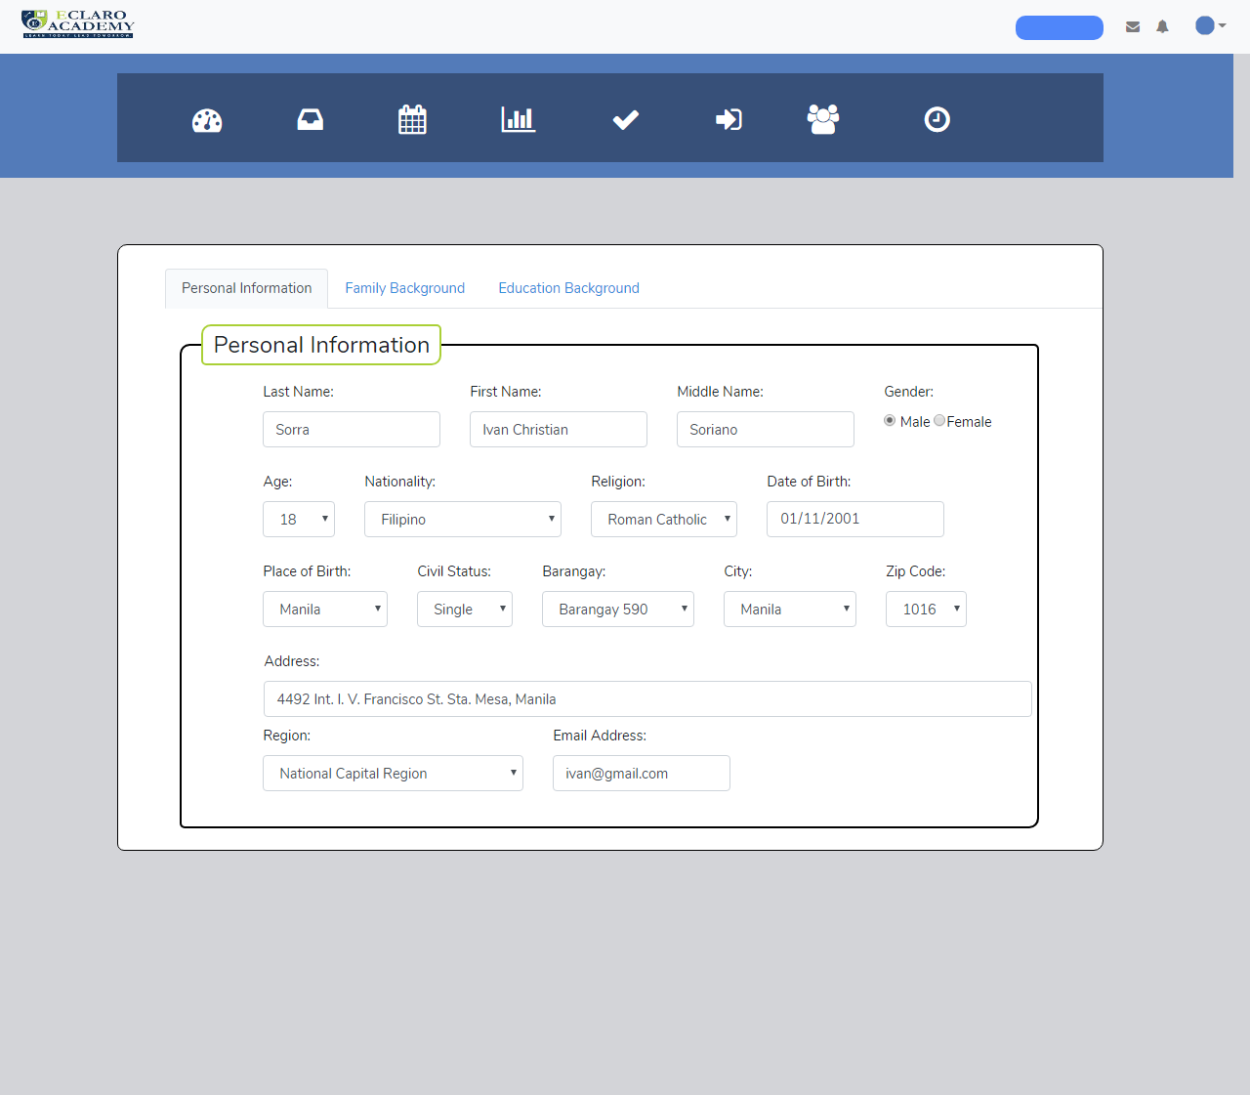

Figure 50 **Students: Edit Profile**

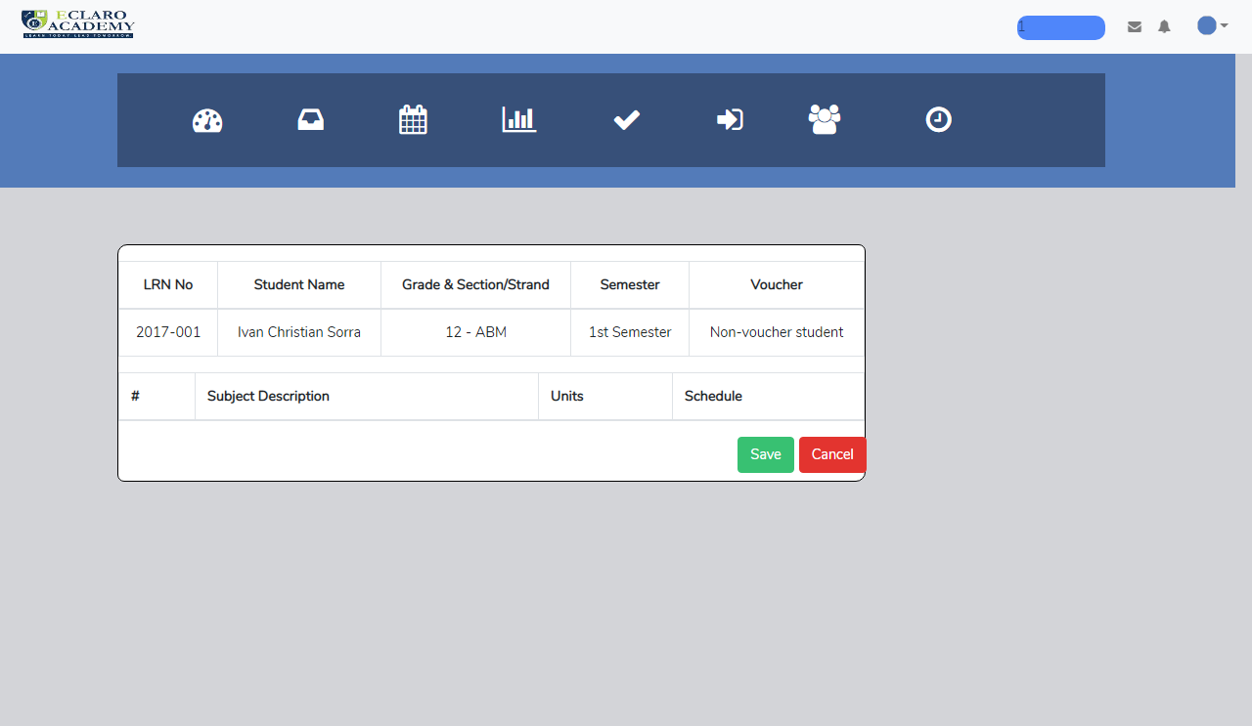

Figure 51 **Online Enrollment**

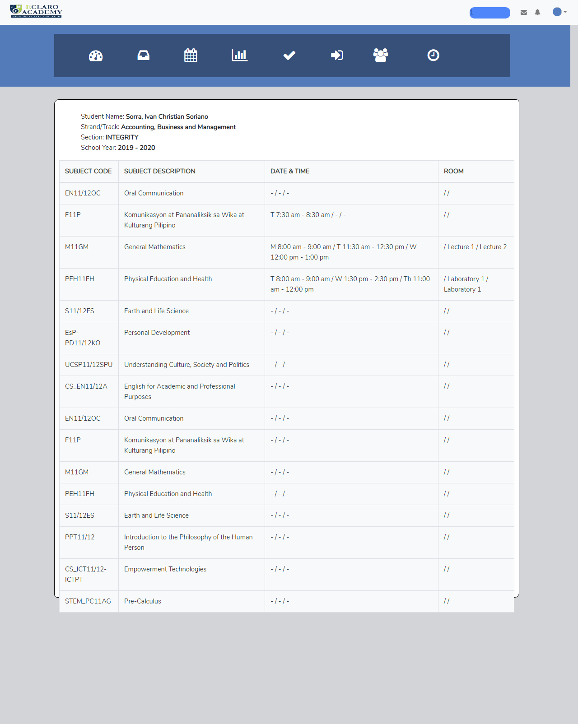

Figure 52 **List of Schedule**

**TEACHERS DASHBOARD:**

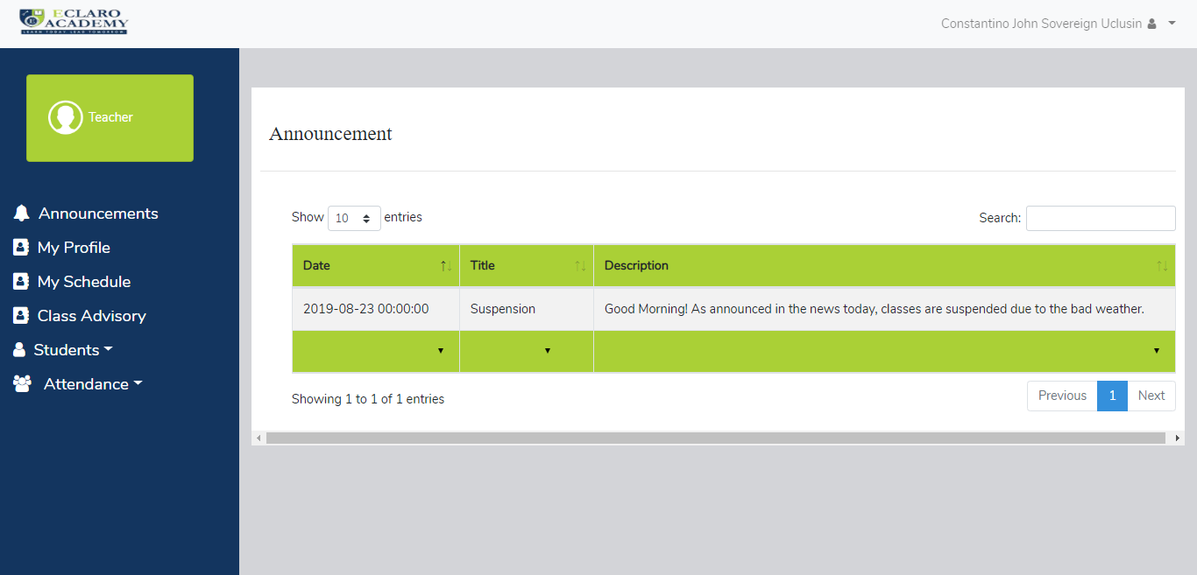

Figure 53 **Announcements (Front Page)**

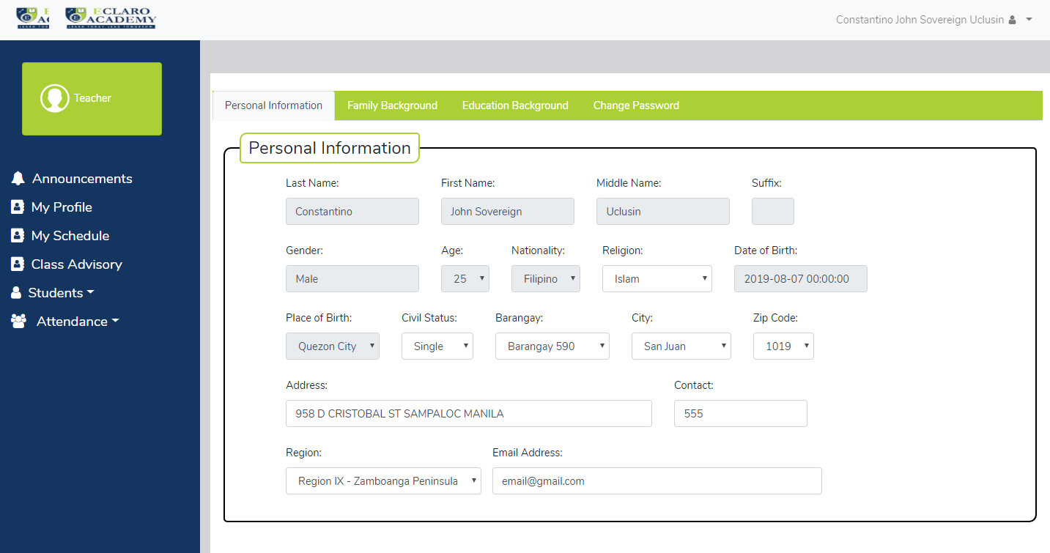

Figure 54 **Teachers Personal Profile**

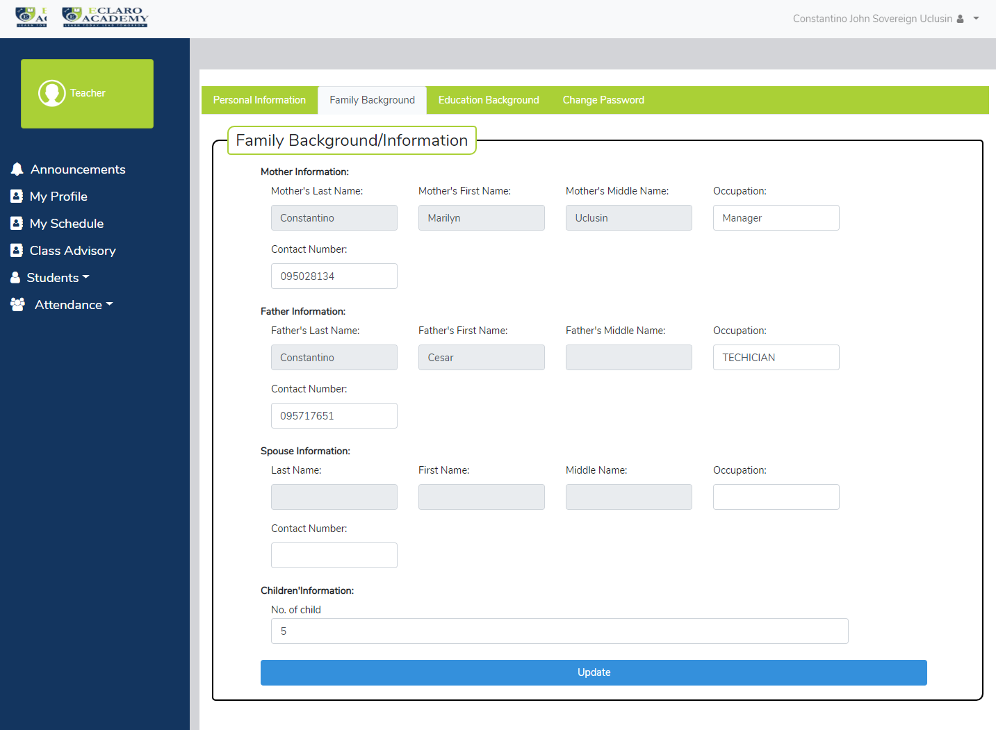

Figure 55 **Teachers Family Background**

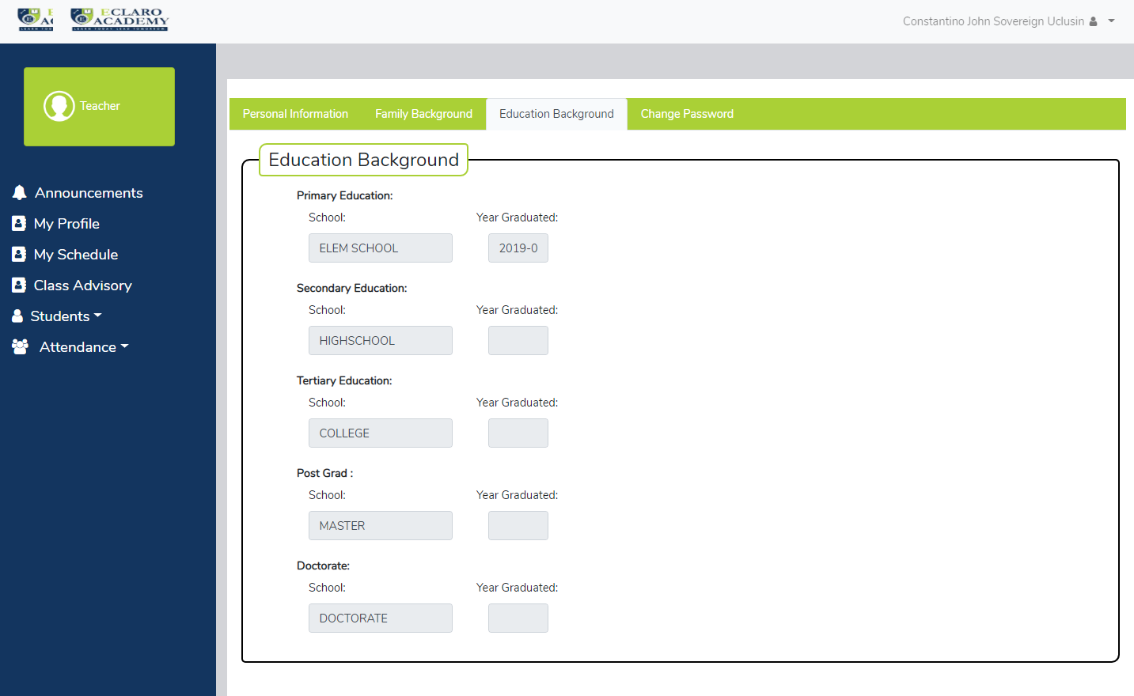

Figure 56 **Teachers Education Background**

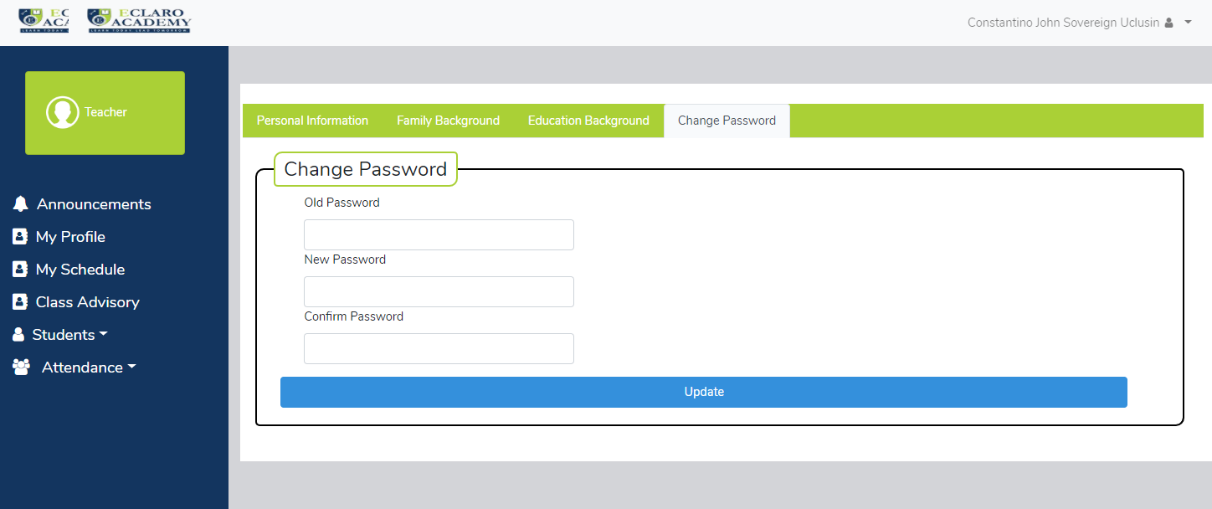

Figure 57 **Change Password**

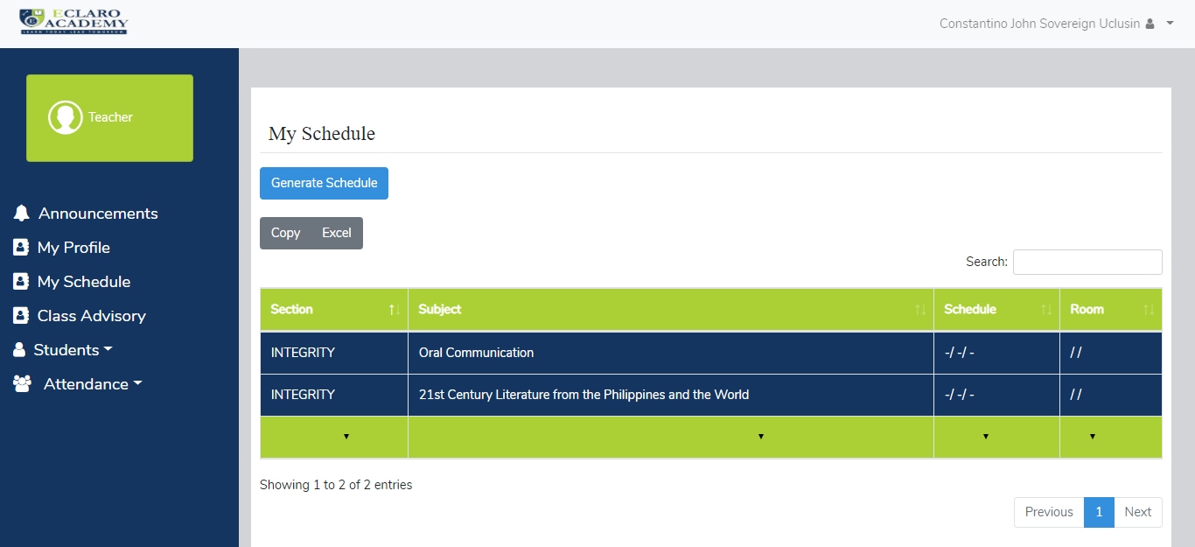

Figure 58 **Teachers Schedule**

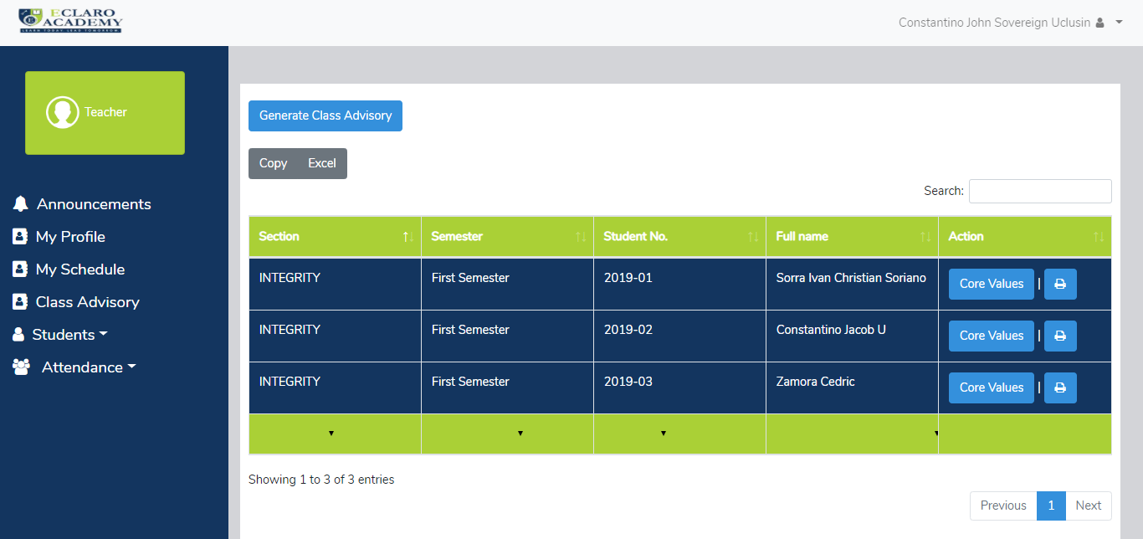

Figure 59 **Advisory Class List**

Figure 59 **Student View Grades**

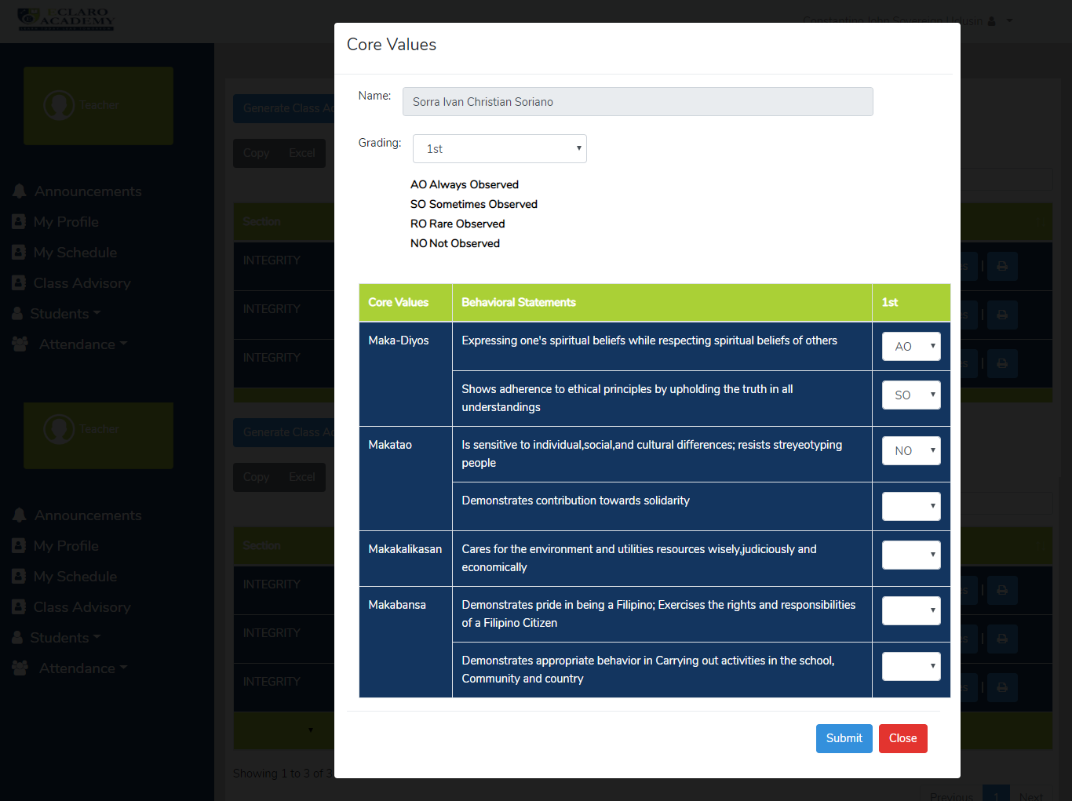

Figure 60 **Teacher Rate Values**

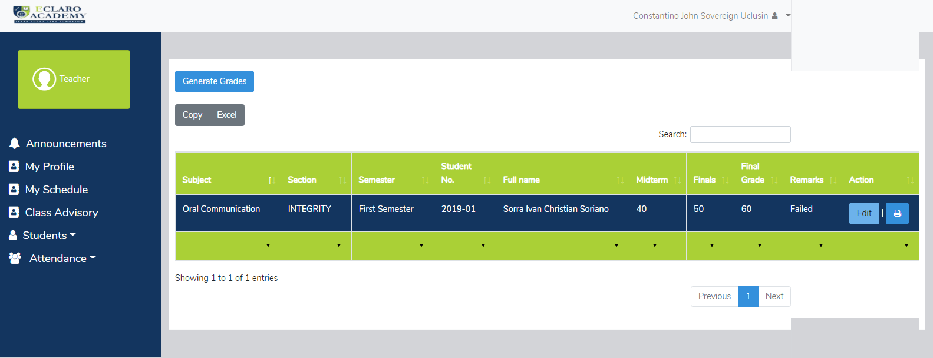

Figure 61 **Teacher Grade Student**

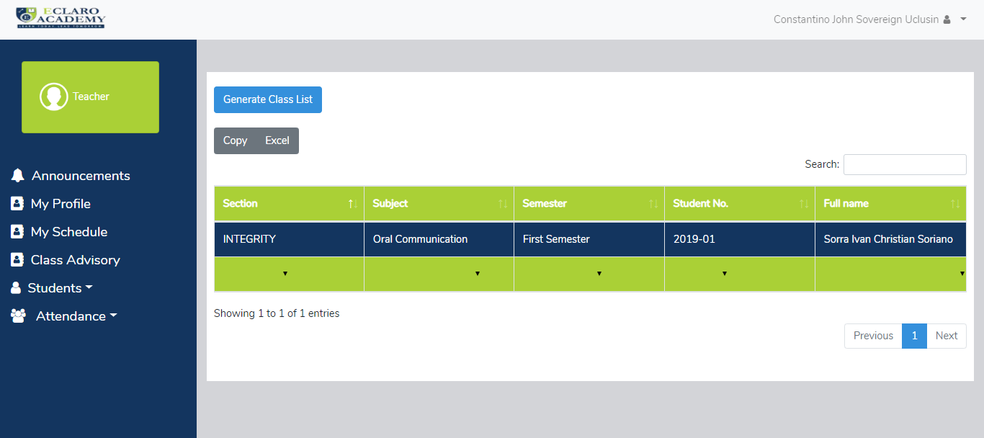

Figure 62 **Teacher Class List**

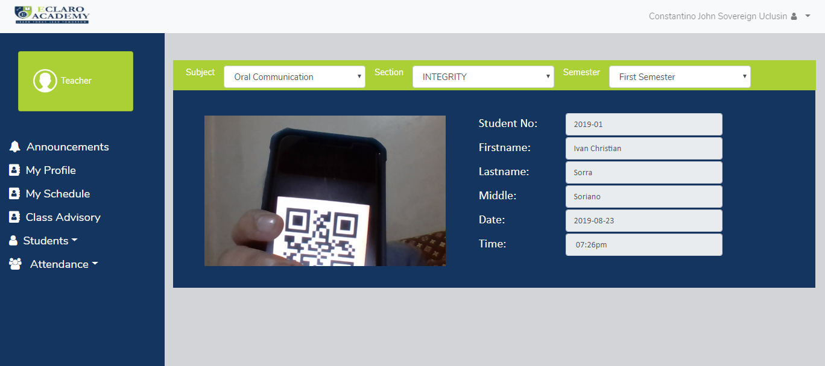

Figure 63 **Teacher Attendance**

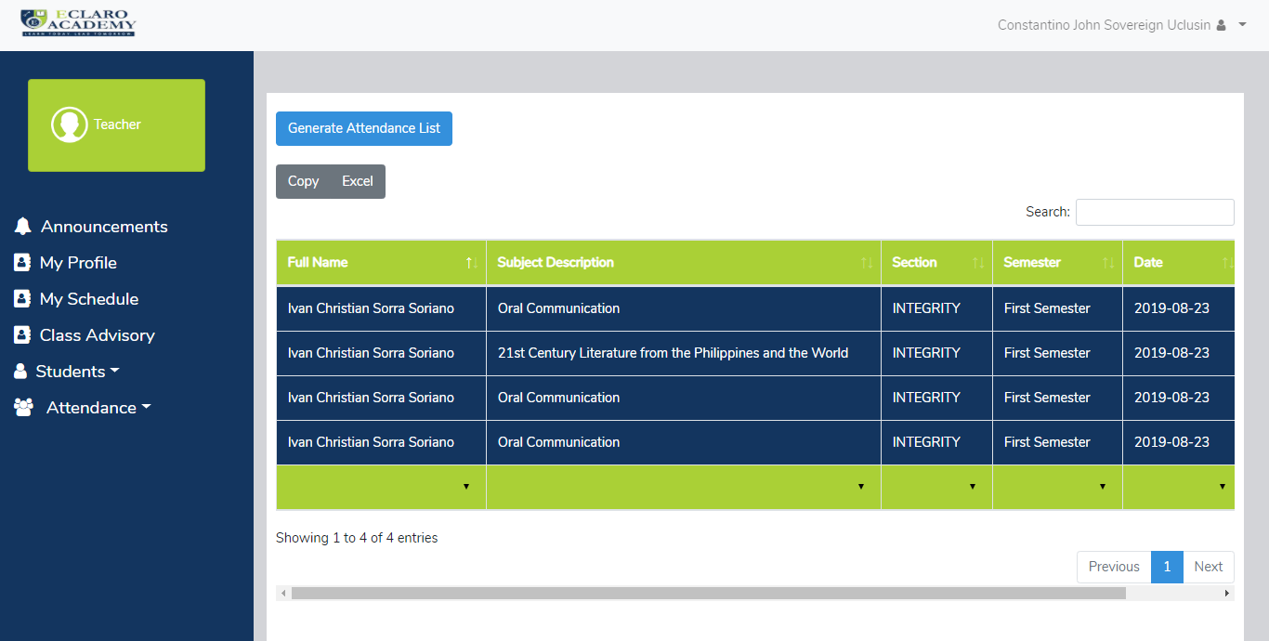

Figure 64 **Teacher Attendance List**

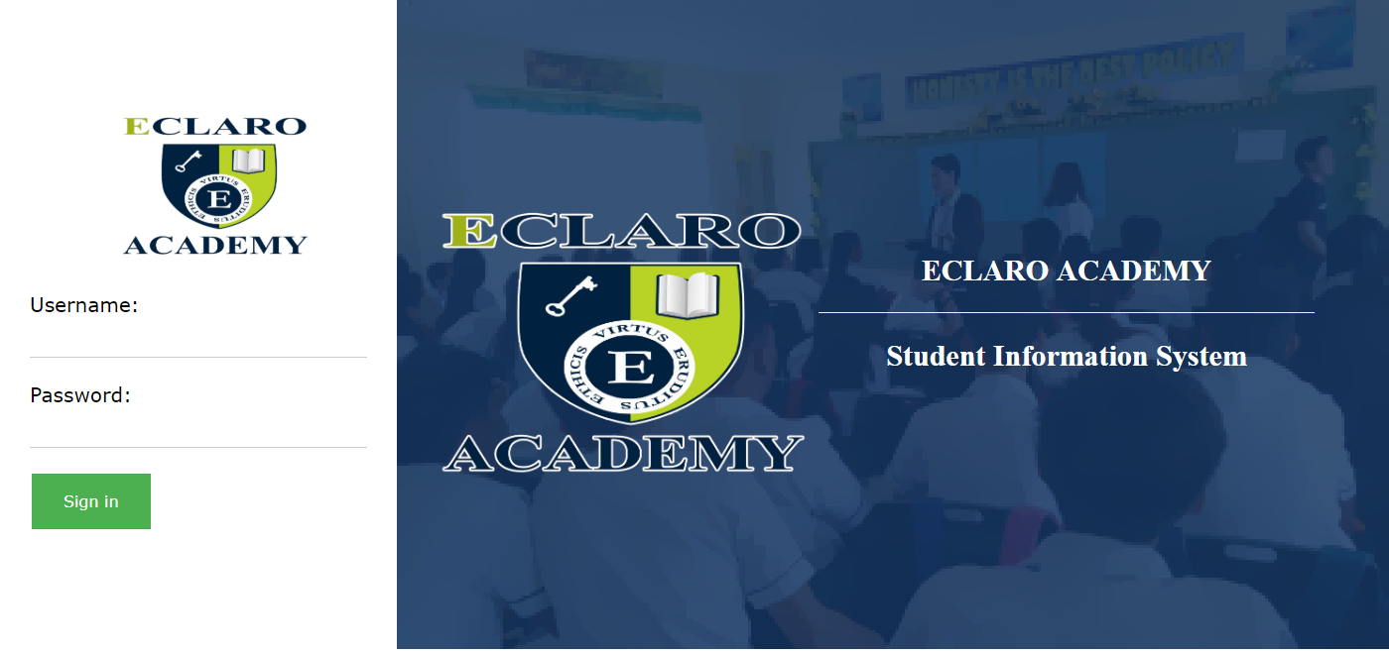**PARENT/GUARDIAN:**

Figure 65 **Parent Login**

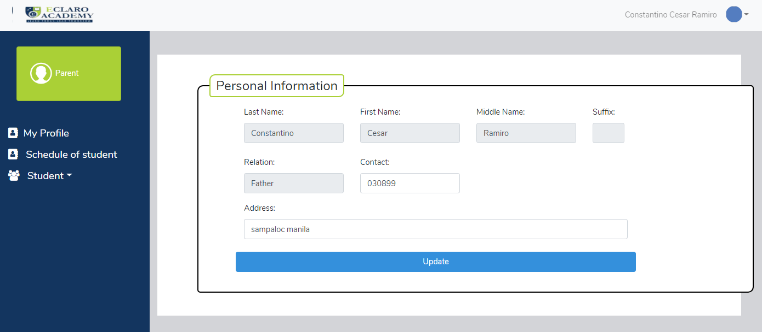

Figure 66 **Parent Profile**

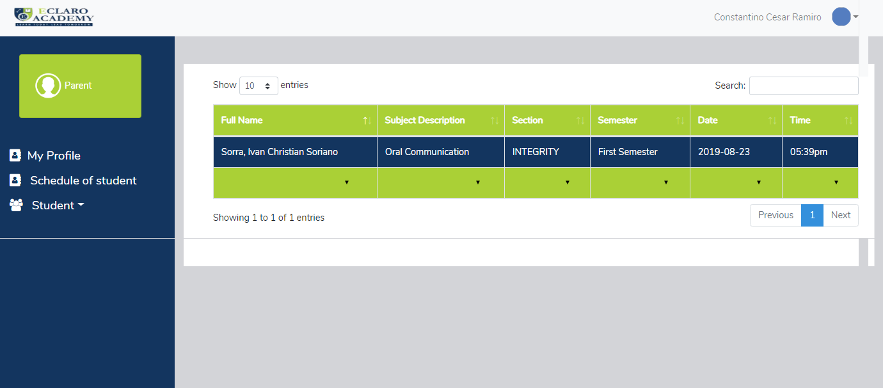

Figure 67 **Parent Student Attendance**

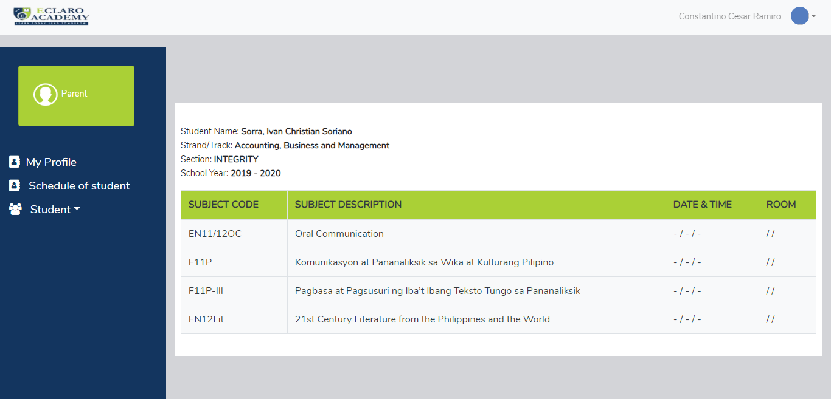

Figure 68 **Parent Student Schedule**

* + 1. 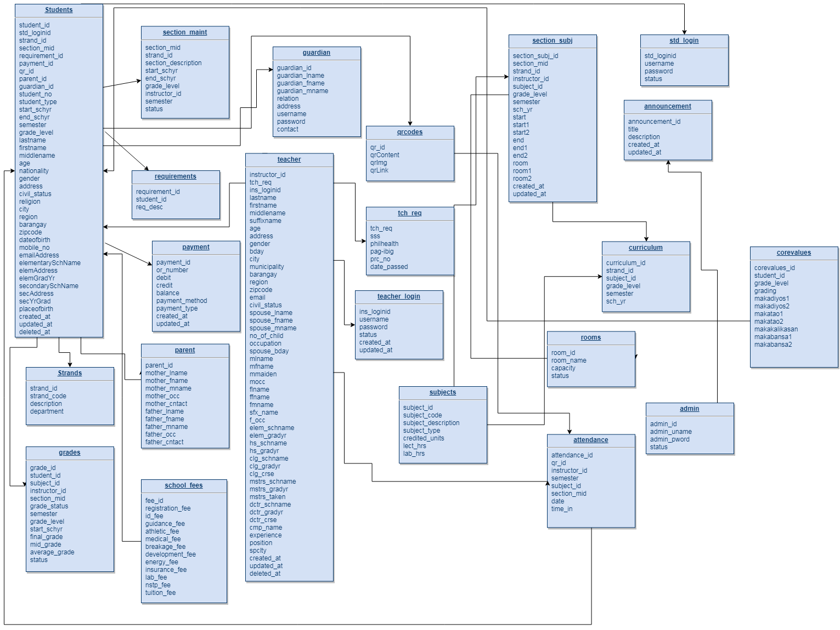Database Schema

Figure 69 **Database Schema**

* + 1. Data Dictionary

Table 16:

Student Table

**Table Name: Student Table**

**Table Description: This table contains all the records of the students**

|  |  |  |  |
| --- | --- | --- | --- |
| **COLUMN NAME** | **DATA TYPE** | **SIZE** | **DESCRIPTION** |
| Student_id | Integer | 11 | Student ID |
| Std_loginid | Integer | 11 | Student Login ID |
| Strand_id | Integer | 11 | Strand ID |
| Section_mid | Integer | 11 | Section ID |
| Requirement_id | Integer | 11 | Requirement ID |
| Payment_id | Integer | 11 | Payment ID |
| Qr_id | Integer | 11 | QR ID |
| Parent_id | Integer | 11 | Parent ID |
| Guardian_id | Integer | 11 | Guardian ID |
| Student_no | Varchar | 30 | Student Number |
| Student_type | Varchar | 20 | Student Type |
| Start_schyr | Varchar | 4 | Start School Year |
| End_schyr | Varchar | 4 | End School Year |
| Semester | Varchar | 100 | Semester |
| Grade_level | Integer | 11 | Grade Level |
| Lastname | Varchar | 20 | Last name |
| Firstname | Varchar | 50 | First name |
| Middlename | Varchar | 30 | Middle name |
| Age | Int | 11 | Age |
| Nationality | Varchar | 30 | Nationality |
| Gender | Varchar | 10 | Gender |
| Address | Text |  | Address |
| Civil_status | Varchar | 20 | Civil Status |
| Religion | Varchar | 20 | Religion |
| City | Varchar | 20 | City |
| Region | Varchar | 100 | Region |
| Barangay | Varchar | 255 | Barangay |
| Zipcode | Integer | 11 | Zip Code |
| Dateofbirth | Date |  | Date of Birth |
| Mobile_no | Int | 11 | Mobile Number |
| EmailAddress | Varchar | 30 | Email Address |
| elementarySchName | Varchar | 50 | Elementary School Name |
| ElemAddress | Text |  | Elementary Address |
| ElemGradYr | Varchar | 4 | Elementary Grade Year |
| secondarySchName | Varchar | 50 | Secondary School Name |
| SecAddress | Text |  | Secondary Address |
| SecYrGrad | Varchar | 4 | Secondary Year Graduation |
| Placeofbirth | Varchar | 20 | Place of Birth |
| Created_at | Timestamp |  | Created at |
| Updated_at | Timestamp |  | Updated at |
| Deleted_at | Timestamp |  | Deleted at |

Table 17:

Student Login

**Table Name: Std_login**

**Table Description: This table contains the Student Login**

|  |  |  |  |
| --- | --- | --- | --- |
| **COLUMN NAME** | **DATA TYPE** | **SIZE** | **DESCRIPTION** |
| Std_loginid | Integer | 11 | Student Login |
| Username | Varchar | 30 | Username |
| Password | Varchar | 255 | Password |

Table 18:

Strands

**Table Name: Strands**

**Table Description: This table contains the strands of the students**

|  |  |  |  |
| --- | --- | --- | --- |
| **COLUMN NAME** | **DATA TYPE** | **SIZE** | **DESCRIPTION** |
| Strand_id | Integer | 11 | Strand ID |
| Strand_code | Varchar | 255 | Strand Code |
| Description | Varchar | 255 | Description |
| Department | Varchar | 50 | Department |

Table 19:

Section Maintenance

**Table Name: Section_maint**

**Table Description: This table contains the section maintenance**

|  |  |  |  |
| --- | --- | --- | --- |
| **COLUMN NAME** | **DATA TYPE** | **SIZE** | **DESCRIPTION** |
| Section_mid | Integer | 11 | Section ID |
| Strand_id | Integer | 11 | Strand ID |
| Section_description | Varchar | 20 | Section Description |
| Start_schyr | Varchar | 4 | Start School Year |
| End_schyr | Varchar | 4 | End School Year |
| Grade_level | Integer | 11 | Grade Level |
| Instructor_id | Integer | 11 | Instructor ID |
| Semester | Varchar | 100 | Semester |
| Status | Varchar | 50 | Status |

Table 20:

Requirements

**Table Name: Requirements**

**Table Description: This table contains the student requirements**

|  |  |  |  |
| --- | --- | --- | --- |
| **COLUMN NAME** | **DATA TYPE** | **SIZE** | **DESCRIPTION** |
| Requirement_id | Integer | 11 | Requirement ID |
| Student_id | Integer | 11 | Student ID |
| Req_desc | Text |  | Requirement Description |

Table 21:

Payments

**Table Name: Payments**

**Table Description: This table contains the student payments**

|  |  |  |  |
| --- | --- | --- | --- |
| **COLUMN NAME** | **DATA TYPE** | **SIZE** | **DESCRIPTION** |
| Payment_id | Integer | 11 | Payment ID |
| Or_number | Varchar | 50 | OR Number |
| Debit | Double |  | Debit |
| Credit | Double |  | Credit |
| Balance | Double |  | Balance |
| Payment_method | Varchar | 30 | Payment Method |
| Payment_type | Varchar | 100 | Payment Type |
| Created_at | Timestamp |  | Created at |
| Updated_at | Timestamp |  | Updated at |

Table 22:

QR Codes

**Table Name: QRCodes**

**Table Description: This table contains the QR Codes for attendance**

|  |  |  |  |
| --- | --- | --- | --- |
| **COLUMN NAME** | **DATA TYPE** | **SIZE** | **DESCRIPTION** |
| Qr_id | Integer | 11 | QR ID |
| QrContent | Varchar | 255 | QR Content |
| QrImg | Text |  | QR Image |
| QrLink | Text |  | QR Link |

Table 23:

Subjects

**Table Name: Subjects**

**Table Description: This table contains the school subjects**

|  |  |  |  |
| --- | --- | --- | --- |
| **COLUMN NAME** | **DATA TYPE** | **SIZE** | **DESCRIPTION** |
| Subject_id | Integer | 11 | Subject ID |
| Subject_code | Varchar | 50 | Subject Code |
| Subject_description | Varchar | 255 | Subject Description |
| Subject_type | Varchar | 50 | Subject Type |
| Credited_units | Integer | 11 | Credited Units |
| Lect_hrs | Integer | 11 | Lecture Hours |
| Lab_hrs | Integer | 11 | Lab Hours |

Table 24:

Section per Subjects

**Table Name: Section_subj**

**Table Description: This table contains the section**

|  |  |  |  |
| --- | --- | --- | --- |
| **COLUMN NAME** | **DATA TYPE** | **SIZE** | **DESCRIPTION** |
| Section_subj_id | Integer | 11 | Section Subject ID |
| Section_mid | Integer | 11 | Section Maintenance ID |
| Strand_id | Integer | 11 | Strand ID |
| Instructor_id | Integer | 11 | Instructor ID |
| Subject_id | Integer | 11 | Subject ID |
| Grade_level | Integer | 11 | Grade Level |
| Semester | Varchar | 50 | Semester |
| Sch_yr | Varchar | 100 | School Year |
| Start | Varchar | 100 | Start |
| Start1 | Varchar | 100 | Start 1 |
| Start2 | Varchar | 100 | Start 2 |
| End | Varchar | 100 | End |
| End1 | Varchar | 100 | End 1 |
| End2 | Varchar | 100 | End 2 |
| Room | Varchar | 100 | Room |
| Room1 | Varchar | 50 | Room 1 |
| Room2 | Varchar | 50 | Room 2 |
| Created_at | Timestamp |  | Created at |
| Updated_at | Timestamp |  | Updated at |

Table 25:

Rooms

**Table Name: Rooms**

**Table Description: This table contains the designated rooms for the students**

|  |  |  |  |
| --- | --- | --- | --- |
| **COLUMN NAME** | **DATA TYPE** | **SIZE** | **DESCRIPTION** |
| Room_id | Integer | 11 | Room ID |
| Room_name | Varchar | 100 | Room Name |
| Capacity | Integer | 11 | Capacity |
| Status | Varchar | 50 | Status |

Table 26:

Curriculum

**Table Name: Curriculum**

**Table Description: This table contains the curriculum**

|  |  |  |  |
| --- | --- | --- | --- |
| **COLUMN NAME** | **DATA TYPE** | **SIZE** | **DESCRIPTION** |
| Curriculum_id | Integer | 11 | Curriculum ID |
| Strand_id | Integer | 11 | Strand ID |
| Subject_id | Integer | 11 | Subject ID |
| Grade_level | Integer | 11 | Grade Level |
| Semester | Varchar | 100 | Semester |
| Sch_yr | Varchar | 100 | School Year |

Table 27:

Announcement

**Table Name: Announcement**

**Table Description: This table contains the school announcement**

|  |  |  |  |
| --- | --- | --- | --- |
| **COLUMN NAME** | **DATA TYPE** | **SIZE** | **DESCRIPTION** |
| Announcement_id | Integer | 11 | Announcement ID |
| Title | Varchar | 100 | Title |
| Description | Text |  | Description |
| Created_at | Timestamp |  | Created at |
| Updated_at | Timestamp |  | Updated at |

Table 28:

Admin

**Table Name: Admin**

**Table Description: This table contains the admin**

|  |  |  |  |
| --- | --- | --- | --- |
| **COLUMN NAME** | **DATA TYPE** | **SIZE** | **DESCRIPTION** |
| Admin_id | Integer | 11 | Admin ID |
| Admin_uname | Varchar | 20 | Admin Username |
| Admin_pword | Varchar | 20 | Admin Password |

Table 29:

School Fees

**Table Name: School Fees**

**Table Description: This table contains the school fees**

|  |  |  |  |
| --- | --- | --- | --- |
| **COLUMN NAME** | **DATA TYPE** | **SIZE** | **DESCRIPTION** |
| Fee_id | Integer | 11 | Fee ID |
| Registration_fee | Integer | 11 | Registration Fee |
| Id_fee | Integer | 11 | ID Fee |
| Guidance_fee | Integer | 11 | Guidance Fee |
| Athletic_fee | Integer | 11 | Athletic Fee |
| Medical_fee | Integer | 11 | Medical Fee |
| Breakage_fee | Integer | 11 | Breakage Fee |
| Development_fee | Integer | 11 | Development Fee |
| Energy_fee | Integer | 11 | Energy Fee |
| Insurance_fee | Integer | 11 | Insurance Fee |
| Lab_fee | Integer | 11 | Lab Fee |
| Nstp_fee | Integer | 11 | NSTP Fee |
| Tuition_fee | Integer | 11 | Tuition Fee |

Table 30:

Teacher

**Table Name: Teacher Table**

**Table Description: This table contains the table student**

|  |  |  |  |
| --- | --- | --- | --- |
| **COLUMN NAME** | **DATA TYPE** | **SIZE** | **DESCRIPTION** |
| Instructor_id | Integer | 11 | Instructor ID |
| tch_reg | Integer | 11 | Teacher Register |
| Ins_loginid | Integer | 11 | Instructor Login ID |
| Lastname | Varchar | 100 | Last Name |
| Firstname | Varchar | 100 | First Name |
| Middlename | Varchar | 100 | Middle Name |
| Suffixname | Varchar | 100 | Suffix Name |
| Email | Varchar | 100 | Email |
| Contact | Varchar | 100 | Contact |
| Age | Integer | 11 | Age |
| Address | text |  | Address |
| Nationality | Varchar | 100 | Nationality |
| Religion | Varchar | 100 | Religion |
| Gender | Varchar | 100 | Gender |
| Bday | Date |  | Birthday |
| City | Varchar | 100 | City |
| Municipality | Varchar | 100 | Municipality |
| Placeofbirth | Varchar | 100 | Place of Birth |
| Barangay | Varchar | 100 | Barangay |
| Region | Varchar | 100 | Region |
| Zipcode | Varchar | 100 | Zip Code |
| civil_status | Varchar | 100 | Civil Status |
| Spouse_lname | Varchar | 100 | Spouse Last Name |
| Spouse_fname | Varchar | 100 | Spouse First Name |
| Spouse_mname | Varchar | 100 | Spouse Middle Name |
| No_of_child | Integer | 100 | Number of Child |
| Spouse_occupation | Varchar | 100 | Spouse Occupation |
| Spouse_contact | Varchar | 100 | Spouse Contact |
| Mlname | Varchar | 100 | Mother Last Name |
| Mfname | Varchar | 100 | Mother First Name |
| Mmmiddle | Varchar | 100 | Mother Middle Name |
| Mocc | Varchar | 100 | Mother Occupation |
| Mcontact | Varchar | 100 | Mother Contact |
| Sfx_name | Varchar | 100 | Suffix Name |
| F_occ | Varchar | 100 | Father Occupation |
| Elem_schname | Varchar | 100 | Elementary School Name |
| Elem_gradyr | Date |  | Elementary Graduation Year |
| Clg_schname | Varchar | 100 | College School Name |
| Clg_gradyr | Date |  | College Graduation Year |
| Clg_crse | Varchar | 100 | College Course |
| Mstrs_schname | Varchar | 100 | Masters School Name |
| Mstrs_gradyr | Date |  | Masters Graduation Year |
| Mstrs_taken | Varchar | 100 | Masters Taken |
| Dctr_schname | Varchar | 100 | Doctorate School Name |
| Dctr_gradyr | Date |  | Doctorate Graduation Year |
| Dctr_crse | Varchar | 100 | Doctorate Course |
| Cmp_name | Varchar | 100 | Company Name |
| Experience | Varchar | 100 | Experience |
| Position | Varchar | 100 | Position |
| Spclty | Varchar | 100 | Specialty |

Table 31:

Teacher Register

**Table Name: Teacher Register**

**Table Description: This table contains a Teacher Register**

|  |  |  |  |
| --- | --- | --- | --- |
| **COLUMN NAME** | **DATA TYPE** | **SIZE** | **DESCRIPTION** |
| Tch_req | Integer | 11 | Teacher Register |
| Sss | Integer | 11 | SSS |
| Philhealth | Integer | 11 | Philhealth |
| Pag_ibig | Integer | 11 | Pag-Ibig |
| Prc_ no | Varchar | 20 | PRC Number |
| Date_passed | Date |  | Date Passed |

Table 32:

Parent Table

**Table Name: Parent Table**

**Table Description: This table contains a Parent Information**

|  |  |  |  |
| --- | --- | --- | --- |
| **COLUMN NAME** | **DATA TYPE** | **SIZE** | **DESCRIPTION** |
| Parent_id | Integer | 11 | Parent ID |
| Mother_lname | Varchar | 100 | Mother Last Name |
| Mother_fname | Varchar | 100 | Mother First Name |
| Mother_mname | Varchar | 100 | Mother Middle Name |
| Mother_occ | Varchar | 100 | Mother Occupation |
| Mother_contact | Integer | 20 | Mother Contact |
| Father_lname | Varchar | 100 | Father Last Name |
| Father_fname | Varchar | 100 | Father First Name |
| Father_mname | Varchar | 100 | Father Middle Name |
| Father_occ | Varchar | 100 | Father Occupation |
| Father_cntact | Integer | 11 | Father Contact |

Table 33:

Parent Table

**Table Name: Guardian Table**

**Table Description: This table contains guardian information**

|  |  |  |  |
| --- | --- | --- | --- |
| **COLUMN NAME** | **DATA TYPE** | **SIZE** | **DESCRIPTION** |
| guardian_id | Integer | 11 | Guardian ID |
| Guardian_lname | Varchar | 100 | Guardian Last Name |
| Guardian_fname | Varchar | 100 | Guardian First Name |
| Guardian_mname | Varchar | 100 | Guardian Middle Name |
| Relation | Varchar | 100 | Relation |
| Contact | Varchar | 20 | Contact |
| Address | Text | 100 | Address |
| Username | Varchar | 100 | Username |
| Password | Varchar | 100 | Password |

Table 34:

Attendance Table

**Table Name: Attendance Table**

**Table Description: This table contains the student attendance**

|  |  |  |  |
| --- | --- | --- | --- |
| **COLUMN NAME** | **DATA TYPE** | **SIZE** | **DESCRIPTION** |
| Attendance_id | Integer | 11 | Attendance ID |
| qr_id | Integer | 11 | QR ID |
| Instructor_id | Integer | 11 | Instructor ID |
| Semester | Varchar | 100 | Semester |
| Subject_id | Integer | 11 | Subject ID |
| Section_id | Integer | 11 | Section ID |
| Date | Text | 100 | Date |
| Time_in | Varchar | 100 | Time In |

Table 35:

Teacher Login Table

**Table Name: Teacher Login Table**

**Table Description: This table contains the teacher’s login**

|  |  |  |  |
| --- | --- | --- | --- |
| **COLUMN NAME** | **DATA TYPE** | **SIZE** | **DESCRIPTION** |
| Ins_loginid | Integer | 11 | Instructor Login ID |
| Username | Varchar | 20 | Username |
| Password | Varchar | 20 | Password |
| Created_at | timestamp |  | Created at |
| Updated_at | timestamp |  | Updated at |

Table 36:

Core Values Table

**Table Name: Teacher Login Table**

**Table Description: This table contains the teacher’s login**

|  |  |  |  |
| --- | --- | --- | --- |
| **COLUMN NAME** | **DATA TYPE** | **SIZE** | **DESCRIPTION** |
| Corevalues_id | Integer | 11 | Core Values ID |
| Student_id | Integer | 11 | Student ID |
| Grade_level | Integer | 11 | Grade Level |
| Grading | Varchar | 100 | Grading |
| Makadiyos1 | Varchar | 100 | Makadiyos1 |
| Makadiyos2 | Varchar | 100 | Makadiyos2 |
| Makatao1 | Varchar | 100 | Makatao1 |
| Makatao2 | Varchar | 100 | Makatao2 |
| Makakalikasan | Varchar | 100 | Makakalikasan |
| Makabansa1 | Varchar | 100 | Makabansa1 |
| Makabansa2 | Varchar | 100 | Makabansa2 |

* 1. **DEVELOPMENT METHODOLOGY**

3.3.1 Process Model

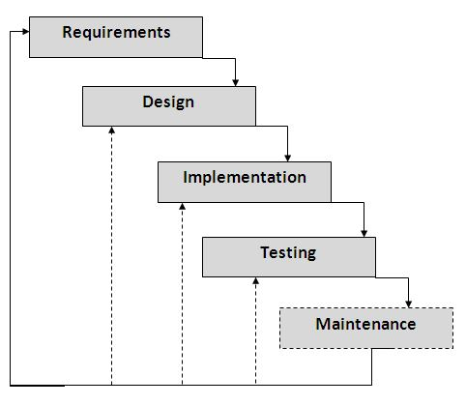

Figure 70 **Waterfall Model**

The proponents used the Waterfall Model because all of the phases in that particular model have been used while making the system for Eclaro Academy. During the Requirement analysis phase, the proponents gathered information from Eclaro Academy, after gathering information, the proponents did the System Designing wherein they planned and designed software that is based on the data they get from the school. The Implementation phase is where the proponents wrote the code for the modules that make up the system. The proponents also reviewed the code and individually tested the functionality of each module. In the Testing phase, all of the modules in the system were tested, making sure that the modules met the requirements. Lastly, the Maintenance phase where any error identified in this phase were corrected and modified the functionality based on the updated requirements.

3.3.2 Development Tools

**Programming Languages**

* **PHP** - Hypertext Preprocessor is a general-purpose programming language originally designed for web development.
* **Javascript** - is a lightweight, interpreted, or just-in-time compiled programming language with first-class functions.

**Database**

* **MySQL** - is a freely available open source Relational Database Management System (RDBMS) that uses Structured Query Language (SQL).
* Servers
* **XAMPP** - is a free and open-source cross-platform web server solution stack package developed by Apache Friends, consisting mainly of the Apache HTTP Server, MariaDB database, and interpreters for scripts written in the PHP and Perl programming languages.

**Frameworks**

* **Laravel PHP Framework** - is a web application framework with expressive, elegant syntax. We’ve already laid the foundation — freeing you to create without sweating the small things.
* **Bootstrap 4 CSS Framework** - is a free and open-source CSS framework directed at responsive, mobile-first front-end web development. It contains CSS- and JavaScript-based design templates for typography, forms, buttons, navigation and other interface components.

**Generators**

* **DOM pdf** – is a HTML to PDF Converter

**IDEs**

* **Sublime Text 3** - is the current version of Sublime Text. For bleeding-edge releases, see the dev builds.
  1. **TEST METHODOLOGY/PROCEDURES**

The proponents test the system by unit testing, a level of software testing where individual units/ components of a software are tested. The purpose is to validate that each unit of the software performs as designed. Integration testing is a level of software testing where individual units are combined and tested as a group it was done to expose defects or errors in the interactions between the different functions of the system. System testing is a level of software testing where complete and integrated software is tested. The purpose of this test is to evaluate the system’s compliance with the specified requirements. Lastly, acceptance testing is a level of software testing where a system is tested for acceptability. The purpose of this test is to evaluate the system’s compliance with the business requirements and assess whether it is acceptable for delivery.

* 1. **SYSTEM REQUIREMENTS**

The system requires a client-server architecture where a server is necessary to host the application and the database. Hardware requirements must be intel dual core processor or later, minimum of 2GB and 4GB recommended of RAM, minimum of at least 250GB of hardware storage, and there must be an internet connection. The system will suitably work for Windows 7 or earlier and in any linux distros. The proponents recommend Google Chrome or Mozilla Firefox as internet browsers to experience the quality of the system.

* 1. **QUALITY PLAN**

The system prioritizes user experience and functionality. In order to ensure and determine the quality required in the development of the system, the efforts were focused not only in the control and verification of quality but also in monitoring if important validations are carried out correctly.

The software quality control instrument used by the proponents on this software development is the ISO 9126-1. It was chosen as the instrument and reference for quality control due to its representation of the latest and on-going research on software quality control, assurance and process improvement. Putting into consideration the 6 characteristics the ISO 9126-1 model identifies: Functionality, Reliability, Usability, Efficiency, Maintainability, and Portability.

Figure 71 **ISO 9126-1 Model**

In order to assess and maintain quality, the following procedures were conducted to monitor the status, progress, and the compliance of the system to the quality standards and requirements:

* Auditing or inspecting the system and its modules to determine its compliance to the standards and requirements.
* Reviewing or examining the system done by both the development team and the client in order to get feedbacks and comments.
* Design inspection in terms of the general requirements of design needed, functional and interface specifications, requirement traceability, logic, performance, error handling and recovery, extensibility.
* Walkthroughs within the team, in order to communicate any query, comment, suggestion regarding possible errors or other issues.
* Functional testing
* Standardization
  1. **EVALUATION PLAN**

Before development, the proponents in coordination with the client have devised a plan for evaluating the system. The plan made use of the 2 categories of evaluation: Formative and Summative. The evaluation plan consists of schedules of meetings, the method of evaluation that is going to be used and the users who are going to evaluate the system. Mainly, the proponents used the monitoring and feedback system and interview with key participants. Summary of the evaluation plan can be seen on Table 37 below.

After development, the proponents designed a survey for end users such as how the students, admin, teachers and parent manage their different module in order to evaluate the end product, to measure the impact and/or success of the system and to reevaluate the modules for comments and suggestions to further improve it. The questionnaire used for the survey consists of 24 questions based on Functionality, Reliability, Usability, Efficiency, Maintainability, Portability, Usefulness, Satisfaction, and Ease of Learning just for the admin, for the teachers consists of 22 for questions, for the students 21 questions and for the parent consists of 14 questions because the system is tailored for Eclaro’s Academy use only and the main concern of the system is user experience and functionality. A sample questionnaire is provided below.

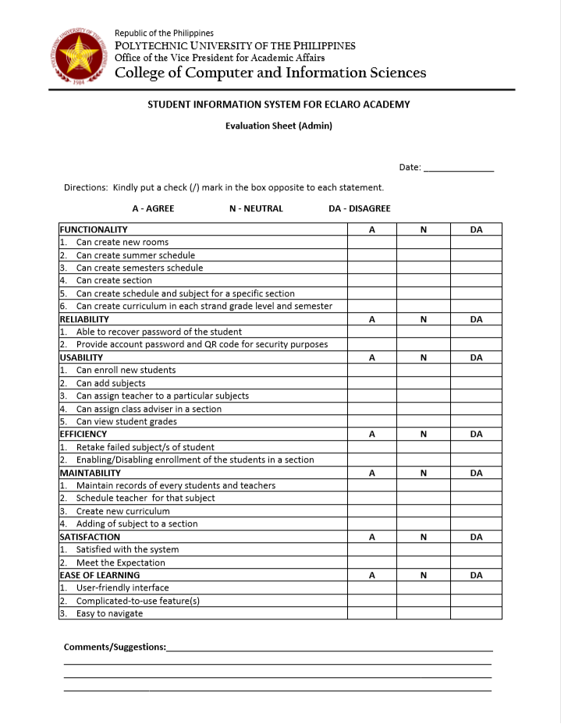

Figure 72 **Admin’s Questionnaire**

# 

Figure 73 **Student’s Questionnaire**

# 

Figure 74 **Teacher’s Questionnaire**

# **Chapter 4 – RESULTS AND DISCUSSION**

# **Chapter 5 – CONCLUSION AND RECOMMENDATIONS**

APPENDIX

**CLIENT FORMS AND REPORTS**

* 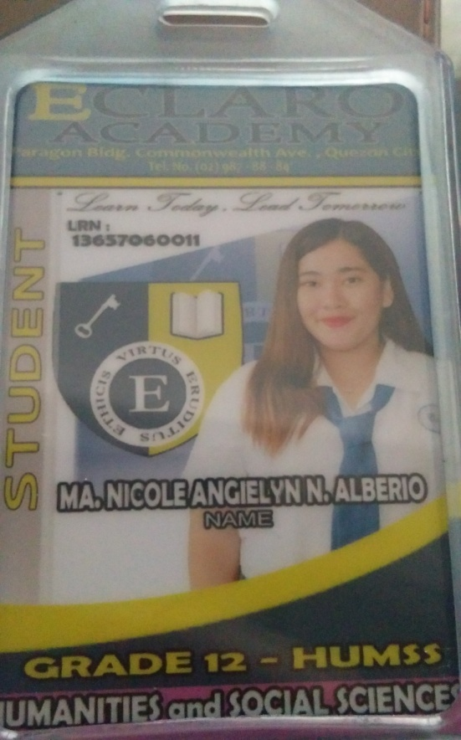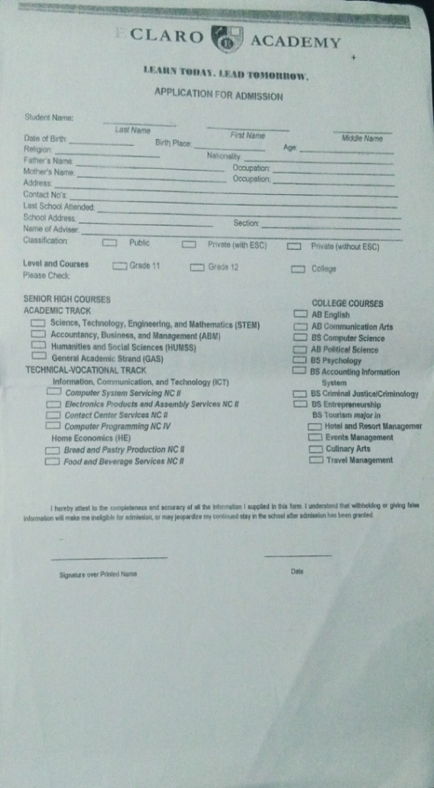**Forms**

***School ID***

***Enrollment Form***

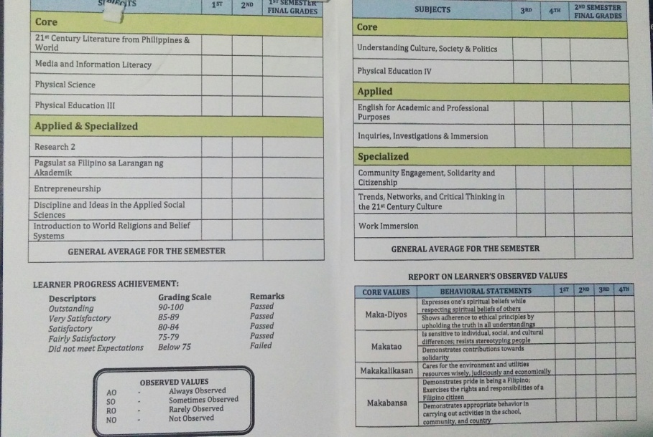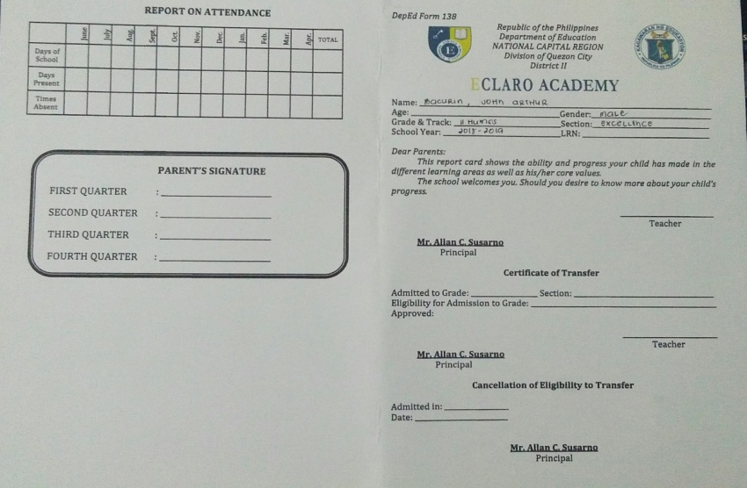

***Report Card (Back)***

***Report Card (Front)***

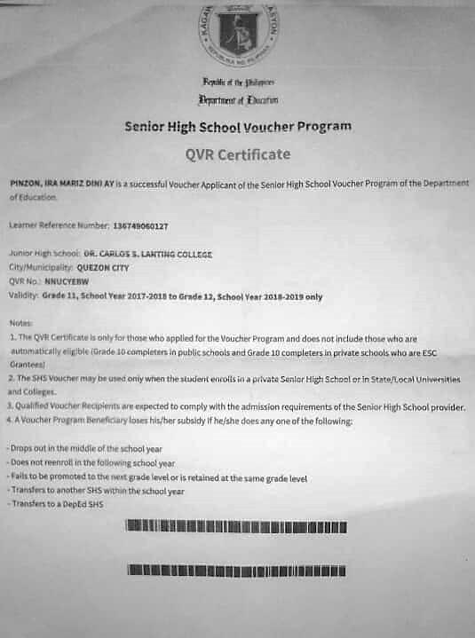

***QVR Certificate (Voucher Program)***

* **Reports**

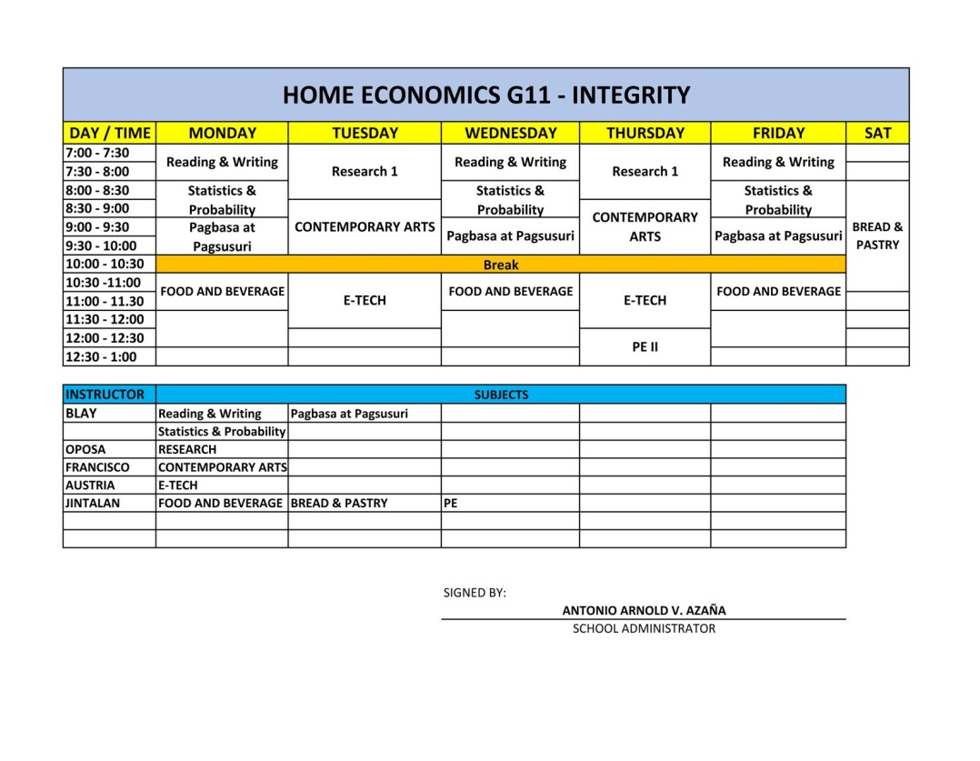

***Schedule of Subjects***

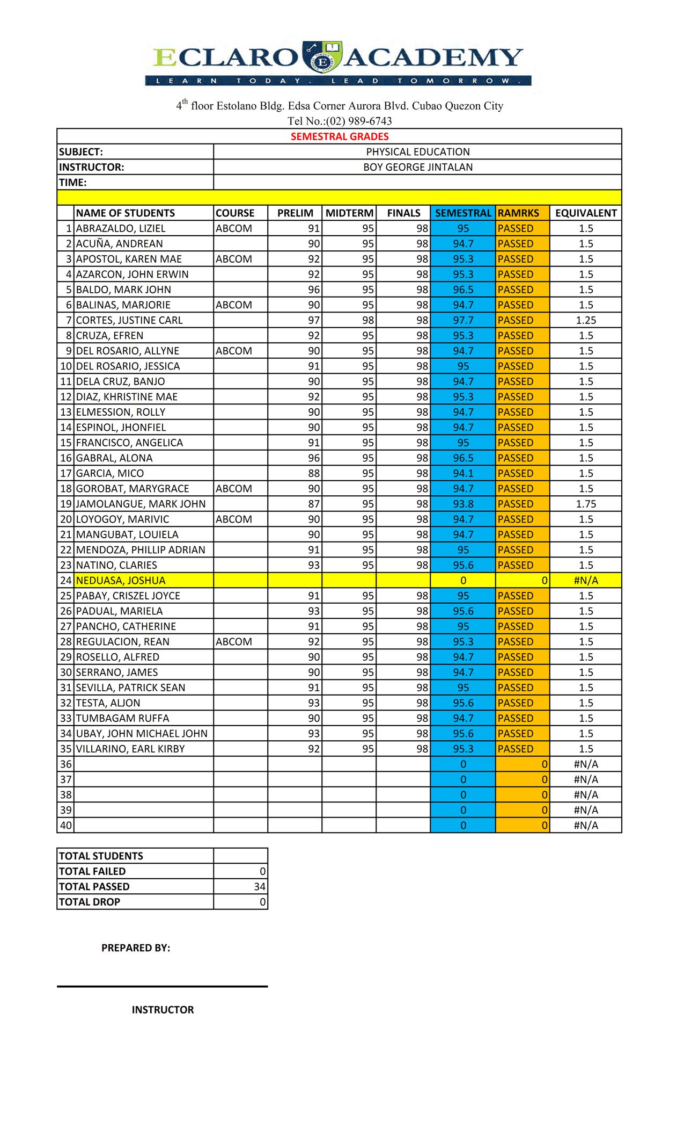

***Summary of Grades***